ne uniuai ruunuauun ui alua—An incemauunai Assuciauun ui seuunuy i^ruiessiunaib

[www.aloa.org](http://www.aloa.org)

**ALOA ‘05**

**Wrapping up a  
Strong Show**

i

PLUS!

**m** Crime Preuention Products

Important / lc

**t** Information **+ %** page 28 **^**

Core

Safes

Mortise Locks

Bylauis Changes and MORE!

***************o££j 3-DIGIT 303 BreckH. CampCML PO Box 47070 Atlanta GA 30362-0070

l„ll.ll.,mll..ll.ml.lllmll.Mi...lll...lmlll 1.1

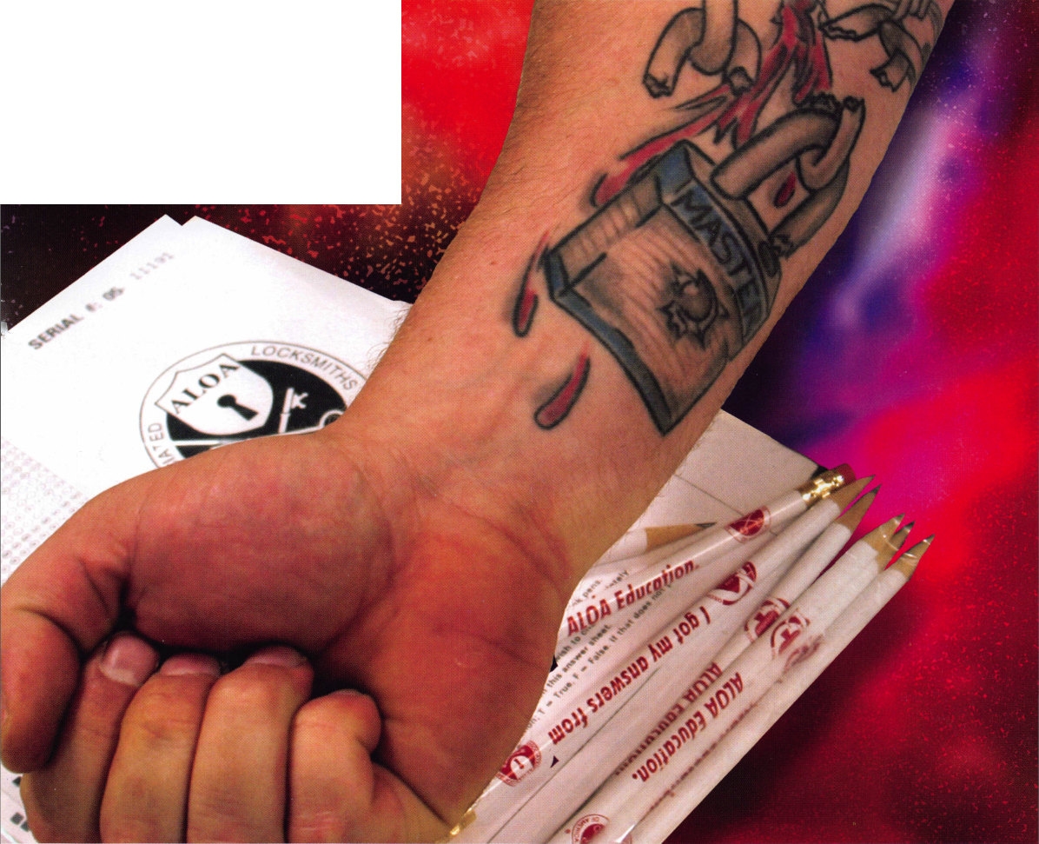

TRUSTED SIDEKICK

***L°CKSHith<.***

**IT'S QUITE POSSIBLY YOUR MOST**

Keep it in Good Hands® with Allstate.

As a small business owner, there are few things you quick certificates of insurance, ID cards, assistance

rely on more than your vehicle to keep you going. with the claims process, and more. All from one of

Your local Allstate agent can help protect it and the most widely recognized names in the business,

your small business with services you need including Are you in Good Hands®?

OUR STAND

1-800-859-0247

CALL NOW TO LOCATE YOUR NEARBY ALLSTATE AGENT.

**/Illstate**

You re in good hands.

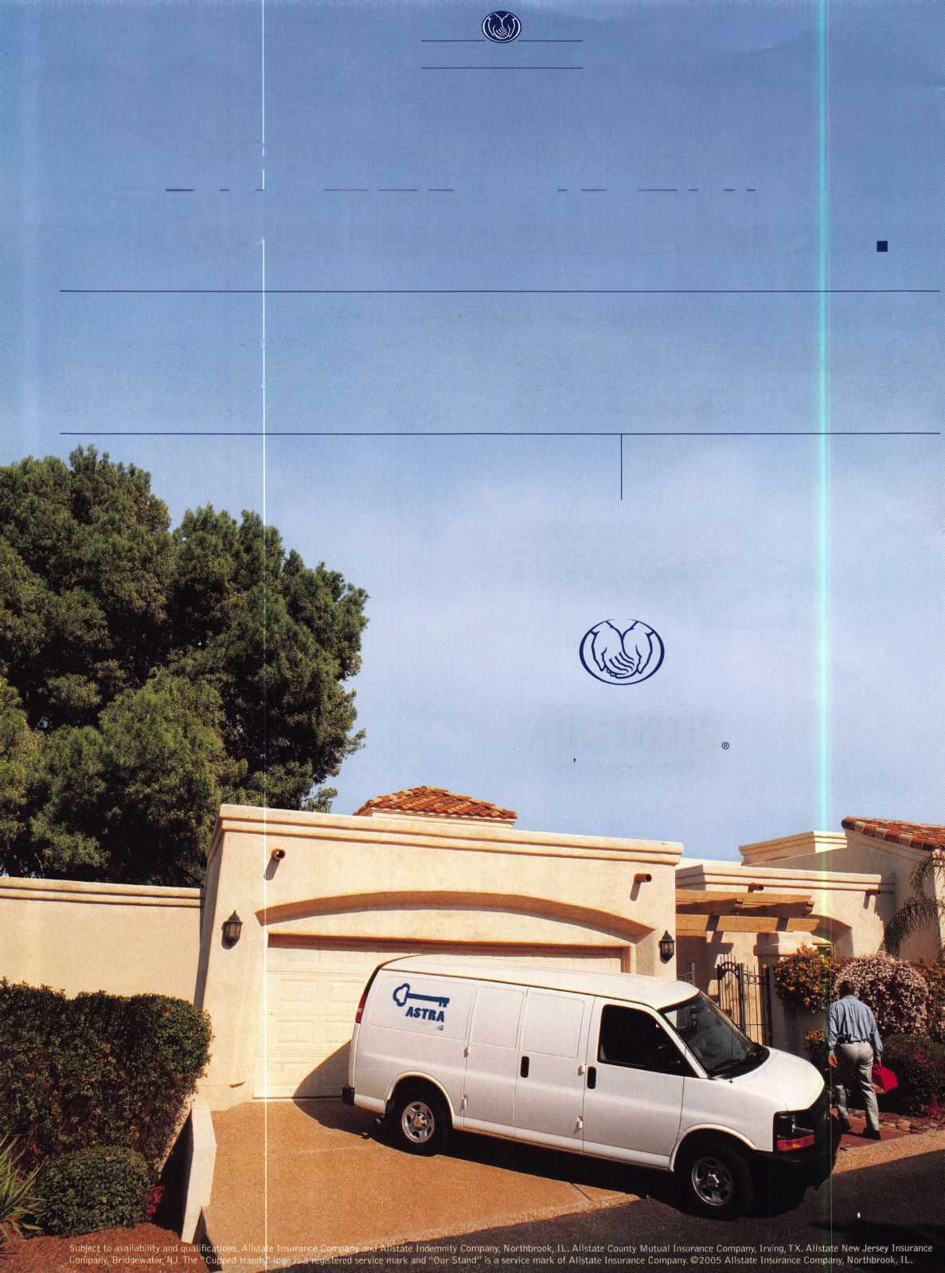

**A Name** You Know

As a business owner, you know the importance of a  
good name. Your name is your reputation. Your name  
stands for all that you offer in products and services.  
It’s a symbol of who you are. So, we thought you  
might like to know that Allstate, the name you know  
for insuring your personal vehicle and your home,  
also offers a business auto policy to help protect vehi-  
cles used in your locksmith business.

The following are coverages typically included in  
our business auto policy that might be important to  
you as a business owner:

Business Auto Liability coverage

* Higher limits up to $2,000,000 per occur-  
  rence.
* Protects you if you are legally responsible  
  for injuries and damages arising out of  
  the ownership, maintenance, or use of  
  business vehicles.
* Cost is based on several factors, including  
  garage location, type and use of vehicle,  
  and the violation and accident activity of  
  your drivers.
* Additional Insured coverage may be  
  required when you contract with govern-  
  mental agencies or bid on local  
  commercial jobs.
* Generally not available on a personal auto  
  policy.
* Usually is no charge to add an insured to  
  a Commercial Auto policy.

Hired Auto coverage

* Provides liability coverage for those  
  vehicles you rent, hire or borrow for  
  business use.
* The premium for hired auto liability  
  coverage is based on the estimated  
  annual rental cost.
* Tools and Special Equipment
* Provides protection to permanently  
  attached equipment on your vehicle.
* You will need to let your agent know the  
  value of the equipment to include in the  
  cost of the vehicle.

You’re good at your business. Your insurance com-  
pany should be the same way.

Contact an Allstate agent to discuss your business  
auto insurance needs. To be referred to an agent,  
please call 800.859.0247 or email

**[abisO@allstate.com](mailto:abisO@allstate.com).**

Subject to availability and qualifications. Insurance coverage  
is subject to policy terms.

Allstate Insurance Company

Allstate Indemnity Company  
Northbrook, IL

Allstate County Mutual Insurance Company  
Irving, TX

Allstate New Jersey Insurance Company  
Bridgewater, NJ

allstate.com

© 2005 Allstate Insurance Company, Northbrook, IL

BETTER  
THAN EVER.

This Hawkeye® Borescope

includes all of the latest upgrades for safe and vault professionals: Optics that deliver images that rival German scopes. A new mirror technology that resists scratches from insulation, asbestos, and burrs. And a mirror protection sleeve to ward off dust.

Plus the option of the GRAND KIT with a fully configured 7” and 17” scope in one case. Or the economy minded LE model.

The red eyecup tells you that you have the scope made specifically for safe and vault professionals.

Available from Gradient Lens resellers to the safe and vault industry only.

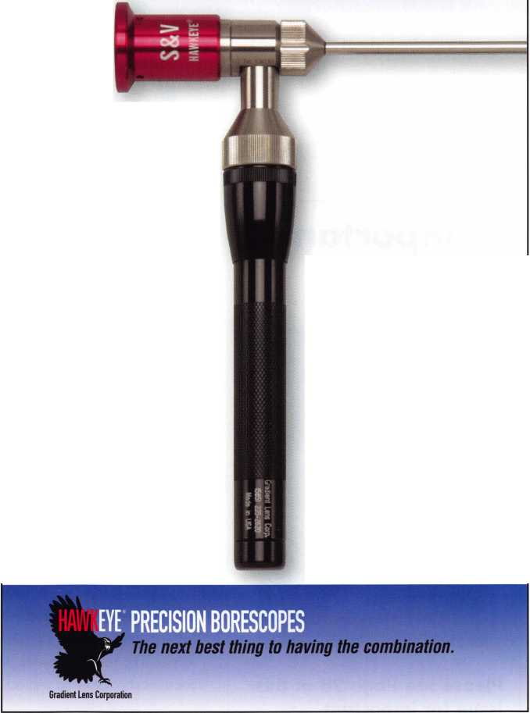

presidentia

viewpoint

Important

Notice



Please see Page 28 of this issue for important changes regarding the ALOA Bylaws.

Dear Members,

Communication-!.To import; convey. 2. To moke known.

1. Intercourse by words, letters or messages; interchange of  
   thoughts or opinions.

Let my first words of communication be those of gratitude to  
all of you for having elected me as your president, and to all  
of our members who gave their valuable time to carefully con-  
sider the candidates and the important changes before us.  
Thank you to all the candidates who ran for the various posi-

tions. You are a fine and dedicated group of individuals who are always willing to give of your  
time and talents to achieve the goals of our association as conveyed by our membership.

ALOA is a great association and it is a great honor to be its president. I am humbled when I think of my illustrious predecessors. The power and prestige of ALOA is greatly reflected in the devotion and loyalty of past leadership. I have complete confidence this current administration will carry forth the same attention to quality and dedication.

To make any progress, we need all of our members to participate. We need to communicate our views about what we want from our association. In addition, it is paramount that we voice our opinions, ideas, and suggestions to others in the industry, which includes manufacturers, wholesalers, other associations, and local as well as federal governments. We are all affected by what happens in our field, now more than ever. Your input is important, and through the Board of Directors, we can secure these goals on this ever changing world-wide stage.

How do we accomplish such a mission? We need to present ourselves in a positive and pro active manner. We are in the physical security industry; we are professionally trained men and women who have the interests of the general publicsi safety as our primary goal. We then must back this philosophy up with action!

As I step up to the office of the president of ALOA, I challenge and charge every member to live up to the highest aspirations of our association. Increase your involvement or become involved. One person CAN make a difference. No one can institute change from the sidelines.

You have placed an obligation on my shoulders and imposed a trust in me. The obligation is welcome, and the trust will be fulfilled.

Take 'er easy!

Sincerely,

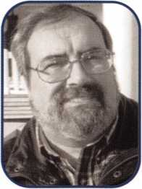

Robert E. Mock

Keynotes • September 2005

V

***Lectro Truck***

STAIR CLIMBINGi SYSTEM

Three strong “grab points” to make handling the stair climber easier.

Detachable battery pack makes swapping batteries simple.

Lectro-Truck nameplate means you get 35 years of product experience.

Break-back bar enables the user to be able to move the heaviest of loads.

Electric Brake stops the drive screw from spinning - no matter how heavy the load.

1-1/2 Hp motor provides the lifting power you need to move up to 1500 pounds.

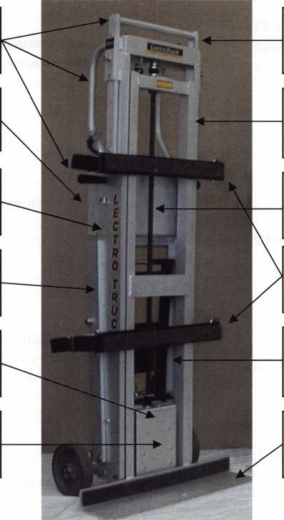

10” extension handle to give the user extra leverage on taller loads.

Heavy duty, aluminum construction makes the unit lighter, yet durable.

3/4” drive screw will not bow - even with loads of up to 1500 pounds.

Two adjustable strap bars allow the user to adjust specifically to each load.

Built-in steel tripod makes moving products down hallways easy.

24” or 30” toe plate width to accommodate individual customer’s needs.

**Model LTA6512E**

Mention this advertisement, and you are eligible for the trade show discount  
that we will have in effect at the ALOA Expo in Chicago July 22-24, 2005.

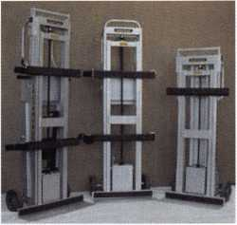

Call us at:

1-800-619-0625

or visit us on the internet at:

[www.lectrotruck.com](http://www.lectrotruck.com)

Innovative Moving Systems, Inc.  
310 South 10th Street  
P.O. Box 700169  
Oostburg, Wl 53070

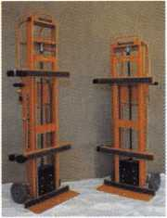

**See us at the ALOA Security Expo - Booth 501**

**features**

CRIME PREVENTION 2005

10

Quality with a Purpose: Better Crime Prevention through Better Design

Robert Boehlow's inspiration for a brilliant new deadbolt design came during the winter of 1989. Warming up his car while he waited inside his house was a common morn­ing ritual for Boehlow. However, every time he left his home, he found it frustrating that he had to walk out to the running car, grab his keys from the ignition, and return to his front door to lock his deadbolt. After walking back to lock his door on a particularly frigid winter morning, Boehlow decided there had to be a better solution.

12

A2 Brutus? Small Format Interchangeable Core...Made Bearable

The interchangeable core has been around since before prohibition but for many in our industry, it is a new world. Some of us have long left the SFIC work to companies like Best or have farmed it out to others because the prospect of learning how to pin these locks or purchasing the equip­ment needed to service them was un-palatable. What we hope to show you with this article is how simple and prof­itable these locks can be.

Jim Hancock, CPL

**18**

Safe Cracking and Snow Chains in July

The safe, manufactured by Security Products Inc. of Texas, was a beast from the beginning. See how author, Greg Perry, CML, CPS tames it with the help of snow chains and two little helpers.

by Greg Perry, CML, CPS

**22**

The Six Biggest Mistakes Made:

How to Spot Business Killers in Action

Think before you take action! Read this article to learn about the six Business Killers that seem to be the root caus­es for many unpleasant situations. Avoiding them can keep you from losing money, valuable customers, and most importantly, your mind!

by John Griswold, CML

**24**

**28**

**30**

Long-Lasting Mortise Locks

Its not a job that you wish for. Its not quick, easy, or even enjoyable until you can sit back and say, "I did that!" Ripping out old mortise locks and replacing them with new ones can be your worst nightmare, or give you your finest bragging rights.

by Eric Costley, CPL

Bylaws Changes Update:

Company Membership

The membership of ALOA approved, by overwhelming majority, seven bylaws changes this summer. Three of these changes substantially altered the requirements for member­ship in the association. Read the first of several installments describing these changes.

Baby; Aren't We Glad We Went?

3,500 Security Professionals from around the world trav­eled to Rosemont, IL in July for the ALOA Convention and Security Expo. The show offered top-notch workshops and classes, an expo and more than one surprise. As always, the show helped security professionals increase their knowledge base and open the doors to a bright new future. Read the post-convention review inside!

**Departments**

Presidential Execir

ViewP°int 2 Appl

five 5

cants 6

Calendar 8

Core 9

Classified 36 Legislative 40

Associate Members 38

Visit our NEW website at [www.aloa.org](http://www.aloa.org)

executive

Volume 51, Issue 8

Additional contact information for the ALOA Board and most Keynotes authors is  
available through "Locksmith Search7" on the ALOA Web site- [www.aloa.org](http://www.aloa.org) or by  
contacting the ALOA office at 3500 Easy Street; Dallas, TX 75247; (800)532-2562; FAX  
(214)819-9736; e-mail [aloa@aloa.org](mailto:aloa@aloa.org).

Editor

Betty Henderson [betty@aloa.org](mailto:betty@aloa.org)

Editorial Advisor

John Cannon, CML [jcannonl@cox.net](mailto:jcannonl@cox.net)

Advertising Sales

Kim Hammond voice: 817-645-6778

Fax: 817-645-7599 e-mail: [adsales@aloa.org](mailto:adsales@aloa.org)

Executive Director

Charles W. Gibson, Jr., CAE [charlie@aloa.org](mailto:charlie@aloa.org)

Associate Executive Director

David Lowell, CML, CMST [david@aloa.org](mailto:david@aloa.org)

Convention & Meetings Manager

Jo Anne Mims [joanne@aloa.org](mailto:joanne@aloa.org)

Operations/Membership Manager

Mary May [mary@aloa.org](mailto:mary@aloa.org)

Director of Creative Services

Betty Henderson [betty@aloa.org](mailto:betty@aloa.org)

IT Operations Manager

Greg Jackson [greg@aloa.org](mailto:greg@aloa.org)

Comptroller Kathy J. Romo

Membership Coordinator Shelly Jett

Convention & Meetings Assistant Karen Lyons

PRP/Education Coordinator Hope Rodriguez

Mail Room Coordinator Kevin Wesley

Creative Media Specialist Bryan Dease

Accounting Coordinator Katie Romo

Administrative Assistant Jen Gilson-Gilliam

Executive Assistant Sue Langford

Assistant Education Manager Bob Stafford

Contributors

Jerome Andrews, CML  
Paul Chandler, CRL  
Claire Cohen, CML  
Brian Costley, CML, CMST  
Eric Costley, CRL

Ray D'Adamo, CML Billy Edwards, CML Dan Graffeo, CRL,CMST Jim Hancock, CPL Jeff Nunberg, CML, CMST

Randy Simpson, CML, CPP Robert Stafford, CML Dave Thielen, CML Greg Perry, CML,CPS

Tom Seroogy

Charles Stephenson, CPS

Dennis Watanabe, CML, CMST

Mission Statement: The Associated Locksmiths of America, Inc. is dedicated to enhancing the professionalism, education and ethics among  
locksmiths and those in related sectors of the physical security industry. With approximately 10,000 members in the United States, Canada and the  
freeworld, ALOA is poised to help members obtain the knowledge, the strength, and the confidence to perform their role in the physical security field  
with pride and dignity. But it is only through active involvement and participation that ALOA can fully achieve its potential—and can help members to  
achieve theirs.

Policies: **Keynotes®** is the official publication of the Associated Locksmiths of America, Inc. (ALOA). **Keynotes**® acts as a moderator without approving,  
disapproving, or guaranteeing the validity or accuracy of any data, claim, or opinion appearing under a byline or obtained or quoted from an acknowl-  
edged source. The opinions expressed by the authors do not necessarily reflect the official views of ALOA. Also, appearance of advertisements and  
new products or service information does not constitute an endorsement of products or services featured by the Association. The Association does not  
accept responsibility for the inaccuracy of any data, claim, or opinion appearing in this publication, due to typographical errors on the part of the  
authors, Association staff or its agents.

Editor's Note: This publication is designed to provide accurate and authoritative information in regard to the subject matter covered. It is provided  
and disseminated with the understanding that the publisher is not engaged in rendering legal or other professional services. If legal advice and other  
expert assistance is required, the services of a competent professional should be sought.

Authors' Payment: Payment for eligible submissions to Keynotes will be based on the following criteria: topic, time spent and past contributions. Authors who  
regularly submit to **Keynotes**® are generally paid a higher rate. The latter is especially true of authors who write to fit specific editorial needs and submit said copy  
by **Keynotes**® deadlines. As a general guideline: Average payment for a 750 word, business or 'light' technical article would be $200. Payment for a 1500 word  
article involving significantly higher time and research efforts would be $400.

Payment will not be offered for articles submitted by ALOA employees or members of the ALOA Board of Directors (unless material is of a technical  
nature), nor for articles submitted by a company that promote that company's products or services. ALOA reserves the right not to pay for articles sub-  
mitted by an individual(s) that promote a particular company's products or services.

Disclaimer: The Associated Locksmiths of America, Inc., (ALOA), reserves the right to refuse any article for any reason. Additionally, ALOA reserves  
the right to edit, amend or modify any article submitted for publication in order to preserve technical accuracy, clarity, fairness or grammatical cor-  
rectness. ALOA will make the best efforts to notify the author of any changes. The extent of ALOA's liability for any article or information contained  
therein will be a notice of correction or retraction in the next possible issue.

**Keynotes**® (ISSN 0277 0792) is published monthly except for the combined June/July issue by The Associated Locksmiths of America, Inc.,  
3500 Easy St., Dallas, TX 75247-6416. Telephone: (214) 819-9733; FAX (214) 819-9736; e-mail [aloa@aloa.org](mailto:aloa@aloa.org). Subscription rates for  
members—$15.00 per year. Periodical class postage paid at Dallas, Texas. POSTMASTER: Send address changes to: Keynotes, 3500 Easy St., Dallas,  
TX 75247-6416. © Copyright 2003, All rights reserved. No part of the contents may be reproduced or reprinted in any form without prior  
written permission of the publisher.



President

Robert Mock  
(856) 863-0710  
[president@aloa.org](mailto:president@aloa.org)

Secretary

John Soderland, CML, CMST  
(414) 327-5625  
[secretary@aloa.org](mailto:secretary@aloa.org)

Directors, Northeast

Peter Sarailian, CRL  
(973)890-9797  
[nedirector@aloa.org](mailto:nedirector@aloa.org)

Vernon Kelley, CPL

1. 771-3126 ned irector@aloa. org

Directors, Southeast

Tom Gillingham, Jr., CML, CPS  
(615)264-0747  
sed irector@a loa. org

Ken Kupferman, CPL  
(813)961-5784  
sed irector@a!oa. org

Director, North Central

William Smith, RL  
(920)893-5282

Guy Spinello, RL  
(815)229-1000  
ncd i rector@aloa. org

Director, South Central

CD Lipscomb, CML, CPS  
(903)874-3522

[scdirector@aloa.org](mailto:scdirector@aloa.org)

Directors, Southwest

Gordon R. Racine, CML  
(719) 384-4707  
[swdirector@aloa.org](mailto:swdirector@aloa.org)

Julie McCluney, CRL  
(714) 636-5652  
[swdirector@aloa.org](mailto:swdirector@aloa.org)

Director, Northwest

Jim Jeffries, CPS  
(208)743-1101  
n wd i rector@aloa. org

Director, European

Hans Mejlshede, CML  
(453)539-3939  
eurdirector@aloa .org

Director, Asian

JoeJ. Lee, CRL  
(215)289-2404  
[asiandirector@aloa.org](mailto:asiandirector@aloa.org)

Director, Associate

Paul M. Justen  
(800)333-6953  
[asdirector@aloa.org](mailto:asdirector@aloa.org)

Trustees

[trustees@aloa.org](mailto:trustees@aloa.org)

Randy Simpson, CML  
(281)240-5959

JohnJ. Greenan, CML, CPS  
(773) 486.2030

William Young, CML, CPS

1. 647-5042

Past Presidents

2003-2005 William Young, CML, CPS  
2001-2003 Randy Simpson, CML  
1999-2001 John Greenan, CML, CPS  
1997-1999 Dallas C. Brooks  
1995-1997 David Lowell, CML, CMST  
1993-1995 Breck Camp, CML  
1991-1993 Henry Printz, CML  
1989-1991 Evelyn Wersonick, CML, CPS  
1987-1989 Leonard Passarello CPL  
1985-1987 Joe Jackman, CML  
1983-1985 Stanley Haney, CPL  
1981-1983 Louis LaGreco, CPL  
1979-1981 John Kerr, RL  
1977-1979 Clifford Cox, CML  
1974-1977 Charles Hetherington  
1972-1974 Gene Laughridge  
197G1972 William Dutcher, RL  
1968-1970 Constant Maffey, RL  
1966-1968 Harold Edelstein, RL  
1964-1966 William Meacham  
1962-1964 Robert Rackiiffe, CPL  
196a 1962 Edwin Toepfer, RL  
1956-1960 Ernest Johannesen



Keynotes • Setpember, 2005

AK

ON

Hadi Wahba

Ironwood

Wasilla

Neil Moss

Sponsor: Arthur A. England CRL



Fountain Hills

Jack Thompson

Sponsor: William Lee CRL

Mesa

Scott Rowley

Sponsor: William Lee CRL

Phoenix

Curtis N. Anderson

Sponsor: William Lee CRL

Valerie E. Lazarovich

Sponsor: William Lee CRL

CA

Coarsegold

Mike L. Cash

Cupertino

Manuel Laranang

Los Angeles

Paul R. Johnson James McKay

Sponsor: Laurie A. Sullivan

Northridge

Thomas Sheehan

San Diego

Terry A. Mooney

Sponsor: John R. Chaco

co

Frisco

Ruth L. McMullen-Campbell

GA

Macon

A

Dubuque

Michael Dorr

L

Algonquin

Joshua D. Brewer

Berwyn

Eduardo Rios

Sponsor: Kurt A. Kloeckner

Collinsville

David Bohnenstiehl

Highland Park

Patrick T. McGahan

Lindenhurst

Bruce Hoff

Midlothian

Chester Donati

Sponsor: Richard E. Fullmer Jr, CPL

Shelbyville

Terry G. Edwards

Stickney

Richard R. Shurlow

Glasgow

Sam E. Bulle

Sponsor: Joseph A/I. Calvert Sr

MD

Glen Burnie

Robert M. Stephan III

Ml

Harbor Springs

Mike Albert

Sponsor: David D. Van Zon

Les M. Harris

Sponsor: John F. Engel CRL

Lapeer

Keith Szukala

Warren

James Heath Sr

MO

Grandview

George Grantham

Imperial

Patrick Chapman

NM

Roswell

Thomas M. liams

OH

Cardington

John C. Hazen

Sponsor: William T. Beranelc

Girard

Dan J. O'Neill

Sponsor: Louis A. O'Neill

OR

Eugene

Mark J. Allen

sc

Columbia

Reynaldo Egipciaco



San Antonio

Peter Peterson

*/A*

Mount Jackson

Brampton

Glen S. Clifford

China

Wuxi, Jiangsu Provi

Zhi Sheng Wu

Sponsor: Kwok-kei Leung

lapan

Tokyo

Kanda Takao

Korea

Dong Dae Moon-Ku Se

Sung-Bae Yang

Sponsor: Chel-Flo Shin RL

Nam Yang JuSi-Gyeon

Kwang-Jong Kim

Sponsor: Chel-Flo Shin RL

Taiwan

Taipei

Anne L. F. Lin

Sponsor: Dong-Hoon Song

United Arab Emirates

Sharjah

Mohamad Albeik

Gerry S. Ford Jeffrey R. Evans

Norcross Sponsor: Raymond B. Fox CPL

These applicants are scheduled for clearance as members of ALOA. The names are published for member review and comment within 30 days of this Keynotes issue date,  
respectively, to ensure applicants meet standards of ALOA's Code of Ethics. Protests, if any, should be addressed to the Membership Department and must be signed. Active  
Membership applicants (a) have worked in the industry two or more years. Allied Membership (AL) applicants are not locksmiths, but work in a security-related field.

Apprentice Membership (AP) applicants have worked in the industry less than two years.

Keynotes • September 2005

GKL Products

Buy it once & use it... again & again...

*Repair Sagging Doors in Seconds!*

Fixes Bent & Worn Hinges Instantly!

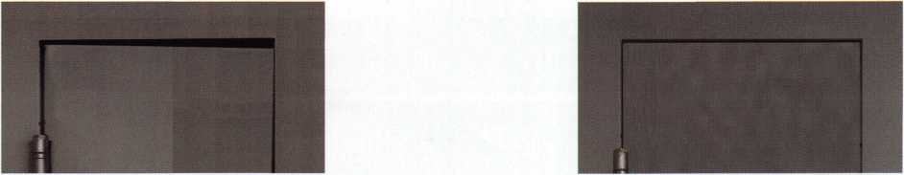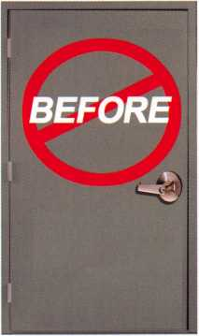

Note Door Hitting Frame

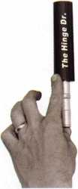

From this to th is

Door is Fixed!!

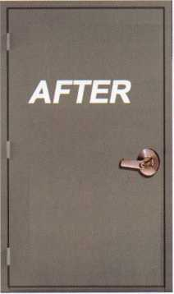

fn seconds..

[www.hingedoctor.com](http://www.hingedoctor.com)

*No more backaches*

*from pulling & rehanging doors!*

*HieHmgeDdsHexeH!*

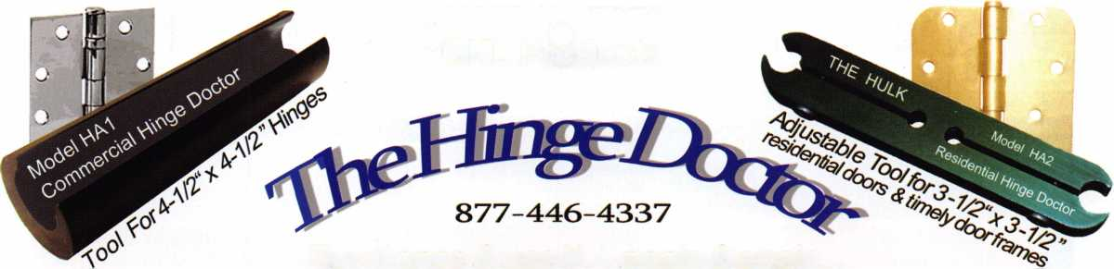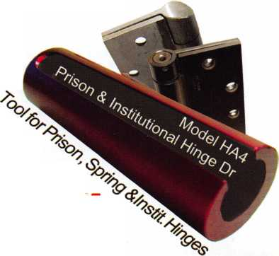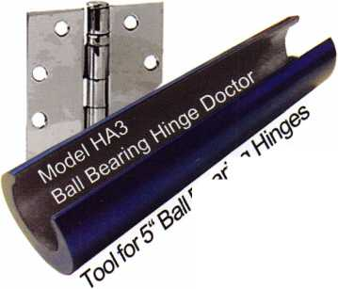

u p c o m

events

i n g

|  |  |  |
| --- | --- | --- |
|  | 25 Clark Security Show | 21 NJMLA Monthly Meeting. |
| 1- | Anaheim, California | Third Wednesday of every month. |
| CL  LU | Contact: Joan Emrick | Call (201)944-7547 or |
| </) | 619-718-7308 | (201)947-6291 for time |
|  |  | and location. |

|  |  |  |  |
| --- | --- | --- | --- |
| 11-15 Pacific Locksmiths Association | 19 NJMLA Monthly Meeting. | 24-29 6-Day Basic Locksmithing | 27-29 GPLA 56th Annual Convention- |
| 2005 Conference | Third Wednesday of every month. | Fox Valley Technical College | Mount Laurel, New Jersey |
| Portland, Oregon | Call (201)944-7547 or | Appleton, Wl 54912-2277 | Contact: Robert Schuetrumpf, CRL |
| ACE Classes, PRP Exam, | (201)947-6291 for time | Contact: Ann Kading | 856-486-9280 |
| Trade Show | and location. | 1-800-735-3882 x2482 |  |

|  |  |
| --- | --- |
| 2-5 Yankee Security Convention | 16 NJMLA Monthly Meeting. |
| ACE Classes, Trade Show & PRP | Third Wednesday of every month. |
| Sturbridge, MA | Call (201)944-7547 or |
|  | (201)947-6291 for time |
|  | and location. |

**UPCOMING ACE CLASSES**

**UPCOMING PRP SITTINGS**

9/24/2005 Casper, Wyoming • Wyoming Locksmiths Association •

Automotive Key Generation/w Strattec Update • Darren McFarland, CRL 307-587-3035

9/24-25/2005 Fort Wayne, Indiana • Northern Indiana Chapter of ALOA •

Complete Door & Door Closers w/L-05 PRP Exit Devices & Exit Alarms w/L-16 PRP Jeremy Rodocker, CML, CPS 260-459-1500

9/30-10/1/2005 Carlsbad, NM • Associated Locksmiths of New Mexico Basic Transponders Life Safety Codes w/L-07 PRP Basic Access Control Roy Haynes, CRL, • 505 746-2133

10/11-15/2005 Portland, Oregon • Pacific Locksmths Association Bill Botek, CRL 503-644-9881 Life Safety Codes w/L07 PRP Fundamental Locksmithing (2 days)

Servicing Aluminum Storefront Doors Safe Combination Lock Servicing Basic Electricity w/L13 PRP Advanced Shop Management Professional Impressioning Techniques

11/2-5/2005 Sturbridge, MA • Yankee Security Convention (9 classes)

Jack Hobin, CPL, • [info@yankeesecurity.org](mailto:info@yankeesecurity.org) 800-209-8266

11/12/2005 Detroit, Michigan • Locksmith Security Association • Robert C.

Nobel, CML 810-385-9329 Large Format 1C w/L-39 PRP

11/19-20/2005 St Louis, Missouri • BiState Chapter of ALOA •

Basic Auto Transponders Systems

Advance Transponders Systems & Keyless Remotes

Robert Theobold 314-340-6804

12/5-10/2005 Dallas, Texas • ALOA ACE Program Hope Rodriguez 800-532-2562 xl04 6 day basic locksmithing course

9/08/2005 Thursday 9:00 am • Dallas, TX • ALOA

Hope Rodriguez 800-532-2562

9/25/2005 Sunday 8:00 am • Anaheim, CA • Clark Security Products

Joan Emrick 619-718-7308

9/25/2005 Sunday 8:00 am • Houston, TX • Houston Safe Extraveganza

Ed Stites 979-240-9083

10/02/2005 Sunday 8:00 am* Des Moines, IA • Iowa Locksmith Association

Harry Russell 319-338-8735

10/02/2005 Sunday 10:00 am • Carlsbad, NM • Associated Locksmiths of New

Mexico • Roy Haynes, CRL • 505-746-2133

10/08/2005 Saturday 9:00 am • Colorado Springs, CO • Central & Southern

Colorado Locksmith Assn ‘Gordon Racine, CML 719-384-4707

10/09/2005 Sunday 9:00 am • Orlando, FL • SERLAC 2005

James Barnhardt, RL 813-689-5979

10/13/2005 Thursday 9:00 am • Dallas, TX • ALOA

Hope Rodriguez 800-532-2562

10/14/2005 Friday 6:00 pm • Portland, Oregon • Pacific Locksmiths Association

Bill Botek, CRL • 503-644-9881

10/30/2005 Sunday 10am • Mt Laurel, NJ • GPLA

Robert Schuetrumpf, CRL 856-486-9280

1 1/5/2005 Saturday 9:00 am • Sturbridge, MA • Yankee Security Convention

Jack Hobin, CPL • 800-209-8266

1 1/10/2005 Thursday 9:00 am • Dallas, TX • ALOA

Hope Rodriguez 800-532-2562

11/12/2005 Saturday 8:00 am • Cary, NC • North Carolina Locksmiths Association

Granger L. Marley, CML 919-859-6060

11/13/2005 Sunday 8:00 am • Baltimore, MD • Clark Security Products

Joan Emrick 619-718-7308

12/08/2005 Thursday 9:00 am • Dallas, TX • ALOA

Hope Rodriguez 800-532-2562

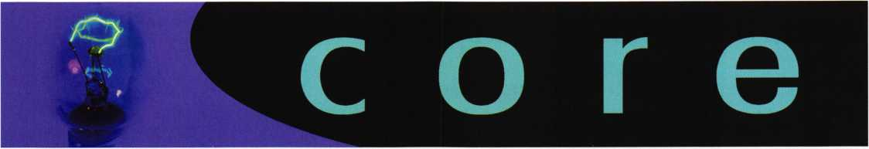

Associated Locksmiths of America Withdraws Support for Legislation

The Associated Locksmiths of America, Inc. (ALOA) recently withdrew support from the "Motor Vehicle Owner's Right to Repair Act" (HR2048). It was hoped that this legislation would help locksmiths gain information about key codes that would ultimately benefit the consumer.

After supporting the legislative process for nearly three years, the locksmith indus­try now believes that there are other, non-legislative, means to reach the same goal. Currently, the Association is working with the National Automotive Task Force (NASTF) to meet these goals.

90 Recognition Systems Biometric HandKey Readers Control Access to Venetian Macau Construction Site

HandReaders provide ultimate biometric solution for quickly letting over 12,000 workers in, keeping others out, and preventing timecard fraud at massive resort/gaming Macau site

Recognition Systems, the biometric component of Ingersoll-Rand's (IR) Security Technologies, recently announced that Solution Expert Technology of Hong Kong has implemented a biometric-based system using 90 HandReaders that controls access for approximately 12,000 workers to all entrances at a construction site that will ultimately be the Venetian'Macau, the anchor of a Las Vegas-style strip for Asia. The Venetian Macau will include 1,500 luxury suites, with an addition­al 1,500 suites planned in Phase II of the development, a million square foot con­vention center, 15 fine dining restaurants, a 15,000-seat arena, a 2,000-seat showroom, and a 600,000-square-foot shopping mall with several additional restaurants.

"Protecting projects from theft and keeping people from getting hurt on construc­tion sites are always a top concern," explains Tony Yuen, COO of Solution Expert Technology. "In Macau, strict labor and safety laws that prevent illegal workers,

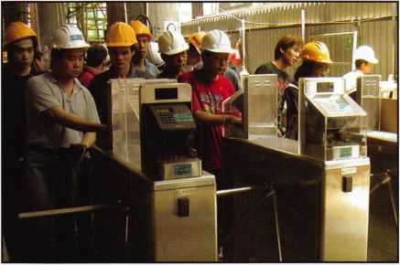

and workers without safety training, from entering construction sites make strict access control even more urgent. General contractors who violate these laws receive heavy penalties when they are caught."

According to Yuen, contractors are increasingly turning to biometric hand geome­try technology to help them quickly give access to authorized workers and accu­rately deny entry to people who should not be on site. With HandReaders, a

worker's permit and safety training records, along with expiration dates, can be entered into a database that not only verifies an employee's identity, but instantly checks to see if that employee is authorized to be there.

HandReaders automatically take a three-dimensional reading of the size and shape of a hand and verify the user's identity in less than one second. At the Venetian Macau, the site is so big that there were concerns that cables would be consistently cut so data is sent wirelessly, using an 802.1 1 wireless router.

Solution Expert Technology has written time and attendance software for both Chinese and English users that interfaces seamlessly with the HandReaders.

Similar systems are used at more than 100 construction sites operated by several of the largest construction companies in Hong Kong.

At the Venetian Macau site, turnstiles are posted at each entrance. A total of 44 turnstiles have been installed at the site so far. The turnstiles create a dual sys­tem with HandReader terminals on both sides, allowing the same turnstile to be used by workers either entering or exiting a site. A contactless smart card, typi­cally kept in a hip pocket, calls up a stored biometric template, which is then immediately validated by placement of the employee's hand on the HandReader terminal. Timekeeping information for the employee is instantly transmitted to a central office wirelessly. Everyone entering the site, from employees to outside subcontractors and vendors, is required to use the HandReaders for access.

The HandReaders themselves are protected by weatherproof stainless steel hous­ings equipped with red/green indicator lights. One set of battery-powered turn­stiles can serve up to 300 workers who enter and exit the site up to six times a day. That means that one set of turnstiles can handle 1,800 transactions per day while still quickly and efficiently providing both timekeeping and access control functions. Over 72,000 transactions are performed each day at the Macau site.

"The portability of our solutions is a key selling point," adds Yuen. "Site entrances are temporary and often moved every three to four weeks. Our turnstile solutions are made to be easily towed from entrance to entrance and site-to-site.

"With the HandReader turnstiles, the construction company can now directly pay all workers, whether they have been hired by subcontractors or not, eliminating potential contract disputes and giving construction companies greater control over their budgets," Yuen continues. "They also have daily access to accurate reports about overall payroll costs. The HandReader terminals also ensure that every person entering a construction site holds a valid safety card and has completed an eight-hour mandatory safety training class.

"What's more, the HandReaders prevent 'buddy punching,' a practice by which one employee punches the timeclock for a coworker who is late or absent and put a lid on the not-uncommon practice of simultaneously punching in at two dif­ferent construction sites. The cost savings to companies from those two issues alone are enormous, accounting for between 3 to 5 percent of overall payroll costs," Yuen emphasizes.

Please Note

In the May 2005 issue, Article "Making Easy Money on a Sentry Gun Safe" the author refers to the lock model as "looking like S&G 6730 import copy".

A statement from Phil Pitt, Director of Marketing for Sargent & Greenleaf states, "Our 6730 and all other S&G mechanical combination locks are manufactured in our plant in Nicholasville KY. We do not import them."



Keynotes • September 2005

Quality with a Purpose

Better Crime Prevention — Through Better Design

The Turner deadbolt is the brainchild of Robert Boehlow of St.  
Louis, Missouri. A mechanical engineer by trade, Boehlow is the  
kind of person who is fascinated by finding practical solutions to  
everyday problems. He is a down-to-earth, pragmatic  
Midwesterner who had a simple vision: to build a more conven-  
ient deadbolt that didn't require a key to engage the lock.

Boehlow's inspiration for this deadbolt came during the winter of  
1989. Warming up his car while he waited inside his house was a  
common morning ritual for Boehlow. However, every time he  
left his home, he found it frustrating that he had to walk out to  
the running car, grab his keys from the ignition, and return to  
his front door to lock his deadbolt. After walking back to lock  
his door on a particularly frigid winter morning, Boehlow decid-

ed there had to be a better solution.

Boehlow started doing his homework, and

realized he wasn't the only one put off  
by the unnecessary step of using a  
key to lock his deadbolt. After

doing some digging, he dis-  
covered that nearly 50 per-  
cent of all people with  
deadbolts on their main  
entry doors fail to lock  
them.

Shortly thereafter, Boehlow  
decided to start building  
what he knew was to  
become the best deadbolt on  
the market. He had a clear

vision of what the finished prod-  
uct would look like, but making it a  
reality wasn't quite as simple. Boehlow  
spent years perfecting his plans for the

deadbolt, and eventually produced a suitable prototype. By the  
mid-1990s, Boehlow was well on his way to a solid design.

Boehlow continued to believe that the lock was an innovative  
product that could succeed in the consumer marketplace. He  
took his lock to a leading wholesale supplier for locksmiths, and  
the company distributed 50 prototype locks to its customer base  
of professional locksmiths for feedback. The industry experts  
were fascinated with the product, and the company was interest-  
ed in licensing the Turner deadbolt. However, they were unable  
to secure a manufacturer.

Soon after, Boehlow met Robert Viviano, who had expertise in  
product development. The two agreed to partner in the develop-  
ment of the Turner deadbolt. Viviano's years of experience in the  
hardware and construction industry brought unique and invalu-  
able insight to the project. Together, Boehlow and Viviano  
worked to refine and co-invent the final patented design.

Viviano also leveraged existing relationships in Asia and his inti-  
mate knowledge of the culture to forge partnerships with overseas  
manufacturers. After years of hard work, Boehlow and Viviano  
were ready to bring the deadbolt to market.

The next step for the two inventors was to partner with Safety by  
Design. The company was developed  
^ around the Turner deadbolt concept

with the belief that it could serve

as a flagship product in a port-  
folio of superior home safety

products. Inspired by their  
straightforward, design-ori-  
ented approach to home  
safety products, Safety by  
Design intends to build  
a full suite of home safe-  
ty products, built from  
the inside out, with the  
consumer in mind.

Safety by Design is a St.

Louis, Missouri-based compa-  
ny that develops thoughtfully engi-

neered home safety products to achieve a  
greater level of safety and security for the con-  
sumer. Engineered to be better, the company’s inspired

product line is designed with a purpose - better protection  
through better design.

Many companies make the claim that technology sets them apart from the competition - the more advanced the product, then the better it must be. Safety by Design’s philosophy is markedly dif­ferent from all other companies in the home safety and security market. Safety by Design provides home safety products that are engineered from the inside out with the consumer in mind.

Their inspired products give consumers the best value with a greater level of safety and security.

“We didn’t start this company to introduce high-tech gadgetry, but rather, to offer intelligent choices to help consumers better



Keynotes • September 2005

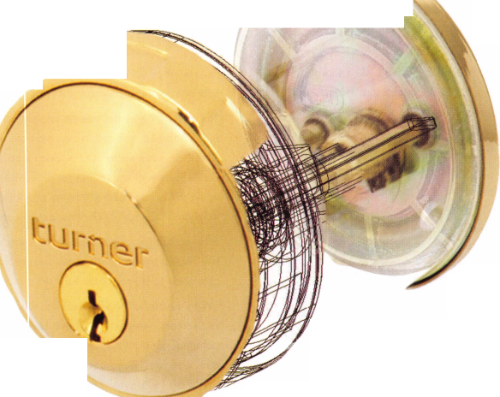

“Safety by Design is continually striving not just to meet  
the standard, but to create a benchmark for all others,”  
says Leinenbach. “Our goal is to help enlighten con-  
sumers, allowing them to make informed decisions when  
it comes to the safety and security of their homes and fam-  
ilies.”

Most residential deadbolts in the United States are certified by the American National Standards Institute (ANSI) as Grade 2 or

even Grade 3. Safety by Design, in  
their continuing mission to provide  
better protection for their customers,  
intends to refine the Turner lock  
until it attains a Grade 1 ANSI-certi-  
fication, the highest rating possible.

To achieve this rating, the Turner lock  
must withstand twice as many blows in  
an ANSI hammer test and endure over

100,000 more cycles than an average  
Grade 2 deadbolt.

Even the strongest deadbolt is useless unless it is  
locked. By eliminating the need for your house key

to lock your deadbolt, the Turner lock makes it easier to  
secure your home and your possessions.

To put the patented locking system in action and secure the

deadbolt, all you have to do is grab the rotating metal collar  
and turn. Just that quickly, your home is protected. No

key, no codes to remember, no alarm to set and no  
monthly fee to pay. Some insurance companies even  
offer lower premiums for homeowners who have dead-  
bolts on all of their exterior doors

The goal of Safety by Design was to develop a lock that

was strong enough to safeguard your home and easy

enough to use that it would blend seamlessly into your every-  
day life. The solution is the Turner lock

- offering better protection through  
better design.

For additional information  
about Safety by Design or  
the Turner lock, please visit  
[www.turnerlock.com](http://www.turnerlock.com), or  
call us at 877.349.0306.

protect themselves and  
their property,” says Steve  
Leinenbach, chief execu-  
tive officer of Safety by  
Design. “While our  
company may be new in  
the marketplace, our  
experienced product devel-  
opers are some of the best

in the business when it comes  
to creating products that will

make consumers safer, without the  
clutter of unnecessary technology and

gimmicks.”

Safety by Design’s first product offering, the Turner dead-  
bolt lock, is a tangible example of the company’s

way of thinking. The Turner is a single-cylin-

der deadbolt that locks from the outside  
with one quick, keyless turn. A rotating  
metal collar on the outside of the dead-  
bolt eliminates the extra step of having to  
insert a key to lock the device. Locking a  
deadbolt with a key seems like a minor  
inconvenience, but a recent study conduct-

ed by the National Crime Prevention Council  
indicates that almost half of the people who have

deadbolts on their exterior doors do not bother to lock them.  
The study goes on to further illustrate that homes without dead-

bolts, or deadbolts that are left unlocked, are up to three times

more likely to be burglarized than homes with properly  
secured deadbolts.

Keynotes • September 2005

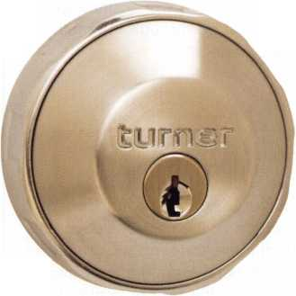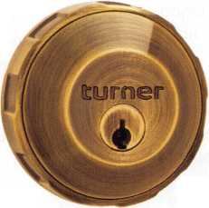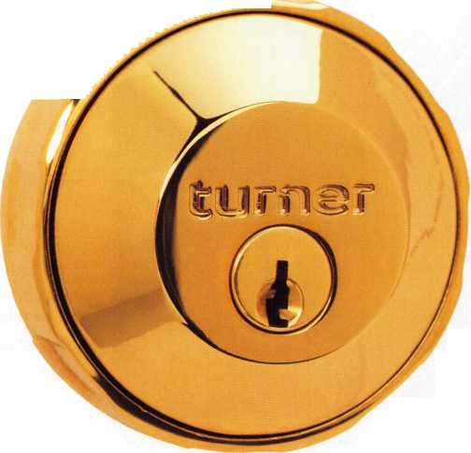

THE CYLINDER

(Illustration 2)

The small format interchangeable core was invented by Frank  
Ellison Best in 1923. The purpose of its design was to allow  
end users to change their locks without knowledge of lock-  
smithing. You would simply insert a control or core key into  
the cylinder and it would allow you to remove the core, intact,

and replace it

with another  
core keyed to  
a different key.  
This is made  
possible by a  
unique design  
in the cylinder  
and the lock  
housings. On  
the cylinder is  
a locking lug.  
This lug pro-  
trudes from the  
side of the  
cylinder at  
about the cen-  
ter of its dis-  
tinctive figure

Chamber

Control

Shearline

Operating

Shearline

Control

Lug

Plug

Keyway

Core Assembly

(Rear View)

illustration

I am reasonably sure that these are not the exact words uttered by Caesar when accosted by his former ally. That is unless; of course Caesar was secretly a locksmith trying to learn the ins and outs of the small format interchangeable core. (Sorry for the fractured history but my article... my history. Next I'll explain how the Titanic actually managed to cross the Atlantic by patching the iceberg induced hole with Lucky Line floating key chains!)

The interchangeable core has been around since before prohibition but for many in our industry, it is a new world. Some of us have long left the SFIC work to companies like Best or have farmed it out to others because the prospect of learning how to pin these locks or purchasing the equip­ment needed to service them was un-palatable. What we hope to show you with this article is how simple and prof­itable these locks can be. We will dissect a small format core and see what makes it function. We will go through the tools needed and finally we will go through the math (yes, the math) to pin the lock cylinders.

TERMINOLOGY

As with every other aspect of the locksmithing profession, there are terms to learn in reference to SFIC.

(refer to illustration 1)

Control Lug (also known as the Locking Lug and Control Cam) - Located on the top portion of the control sleeve, this is the heart of the Small Format Interchangeable Core. This extrusion (big word for us southerners) locks the core into the lock housing and with the use of the proper control key, allows for removal of the core unit.

Control Sleeve - If the Lug is the heart of the SFIC, the control sleeve is the blood feeding this heart. The control sleeve is cylindrical and surrounds the lock plug. There are chambers in the sleeve which align with the chambers in the plug and shell. The width of top of this sleeve is .125", an important fact to remember.

Control Key (also referred to as the Core Key) - This key is used to remove the 1C from its housing.

Control Shearline - This is the shear- line created between the sleeve and the shell to allow Core removal.

Operating Shearline - This is the  
conventional shearline, created between  
the plug and the control sleeve to allow  
lock operation.

Caps (Cylinder Caps, Chamber Caps) -  
Small discs, usually brass or nickel, used  
to cover the chambers of the SFIC core.  
After loading the pins and springs, these  
discs are pressed or tapped into the top  
of each individual chamber. This is com-  
monly referred to as "Best Style" capping.

Slide Cover - This is a chamber cap  
designed by Falcon lock. Instead of indi-  
vidual caps on each chamber, Falcon  
uses a single cap, a small flat piece of

brass or nickel, which gets pressed into a recess in the top  
of the Falcon core, covering all 6 or 7 chambers at once.

Pinning System (Keying System) - SFIC utilizes 3 differ-  
ent systems to determine the pinning of the locks. These sys-  
tems differ in the increments between depths. As with a stan-  
dard pin tumbler cylinder, the greater the depth increment,  
the more security in the system and the fewer change key  
possibilities. These systems are denoted as A2, A3 and A4.  
(more on these later)

31 Ar2

**BRUTUS?**

SMALL FORMAT INTERCHANGEABLE CORE MADE... BEARABLE

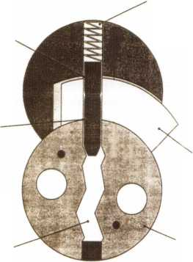

Serving North America

East Midwest West [www.topnotch.bz](http://www.topnotch.bz)

Pennsylvania Missouri Nevada [sales@topnotch.bz](mailto:sales@topnotch.bz)

1 -800-233-4210 1 -800-211 -4607 1 -800-722-4210

Fax: 1 -800-854-4146 Fax: 1 -800-211 -4608 Fax: 1 -800-248-3620

names in electronic security and access — and receive the industry’s best product backing.

HES electric strikes, the strongest and best performing  
on the market, accommodate every type of lockset.

Securitron’s award-winning Magnalocks, with the  
“MagnaCare” lifetime warranty, complement its full line of

power supplies, brackets and accessories, digital entry

systems, touch-sensitive devices, push buttons, and key switches.

And best of all, when you order HES and Securitron products from Top Notch, you’re getting the best service in the industry — with huge inventory, fast turnaround, exceptional product knowledge, and 12+ hours of daily personal sales support. We’re ready to take your call.

illltsISS

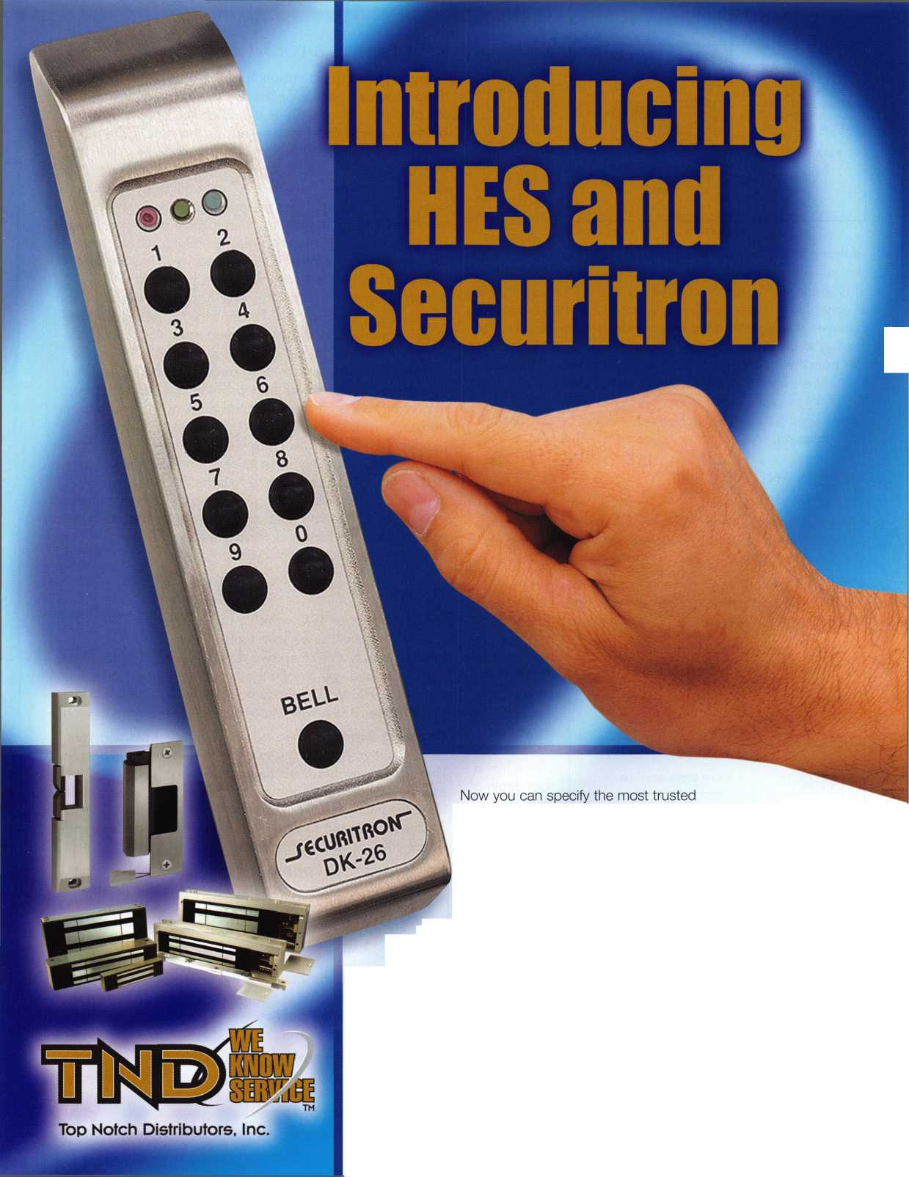

8 shape.

This lug  
holds the  
cylinder in  
its housing  
by locking  
into a void  
in the hous-  
ing. The lug  
serves anoth-  
er purpose

in that it is this lug, or rather the sleeve it is attached to,  
that allows the creation of a secondary shear line point.

This shear line point controls the position of the lug. When  
a control key is inserted into the lock, it creates a shear line  
between the lug and the outer cylinder shell which allows  
the lug to be pulled inward. This action releases the cylin-  
der from the housing and allows it to be removed. The tradi-  
tional shear line between the plug and the control sleeve at the  
top of the plug allows the operating key to activate the lock  
while keeping the lug securely intact, holding the cylinder unit  
in the housing.

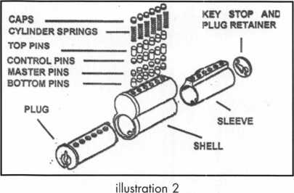

DEPTHS AND SPACING (Illustration 3)

Since this article is titled "A2" we will focus on the A2 sys­tem depths and spacings however later we will also give you the info for A3 and A4.

On an A2 system, the increments between depths is

.01 25". The smallest or shallowest depth for a bottom pin is

a "0" cut which measures has a root depth of .1 1031 8"

and has a

pin length of  
.110", the  
largest or  
deepest  
depth is a  
"9" cut  
which has a  
root depth of  
.206 and  
has a pin  
length ofgoes  
to a depth of  
"9" which

|  |  |
| --- | --- |
| DEPTH  OF CUTS | |
| 0 | . SI 8 |
| 1 | . 306 |
| 2 | . 28$ |
| 3 | .281 |
| 4 | .288 |
| S | .256 |
| S | .243 |
| 7 | ,231 |
| 8 | .218 |
| 8 | .208 |

SPACING BETWEEN CUTS « .ISO

measures  
.222". The  
top pins

illustration 3 (master/con-

trol/driver depending upon usage) begin with a number 2  
which measures .025" and progresses to a number 19 measur-  
ing .238". The cut to cut centers are . 150". The cut angles are  
approximately 90 degrees with a root width of .054". Because  
of this, the Maximum Adjacent Cut Specification is "9" which  
allows for the maximum available usable change keys, although  
a 909, 919 or 808 combination is not recommended.

KEY CUTTING & LOCK PINNING

These keys are are a variation of the a tip stop key in that there is not a shoulder on the key to stop its insertion into the plug but rather, there is a stop on the bottom of the key blade which contacts the key stop in the rear of the plug to restrict its travel. Because this is a "tip stop" key, the cuts are numbered from tip to bow with the #1 cut being at the end of the key and the #6 or #7 cut being closer to the bow. This is important to remember because most key machines will cut the key from tip to bow and all pinning is computed from tip to bow. There is nothing worse than repinning a core 2,3 or 10 times and realizing the reason it doesn't operate is that you you are pinning it in the wrong direction, (not that this ever happened to me person­ally but I've heard stories). Perhaps the biggest difference in pinning the locks is that you need not disassemble the plug and shell. In fact, it is virtually impossible to pin the locks correctly if you take them apart. All pinning is done through the chambers at the top of the shell. Bottom pins, master pins when needed, control pins, drivers top pins and springs are all loaded through the top. This also is handy when you are working within a master key system because you may only have to eject and change the pins and spring in one chamber to facilate the use of a new change key. Because of this, it is critical that you do the pinning math correctly and trust your pin kit because you will not have the luxury of visually seeing the shear line as on a standard pin tumbler cylinder.

TOOLS

This is the part of SFIC work that you will either love or  
hate. As locksmiths, we love tools (toys to us really). As  
businessmen and women, we do not want to spend money  
needlessly and will usually try to get by without. When it  
comes to SFIC tools, there is no "getting by". Without the  
proper tools, it is nearly impossible to do this type of work.

Capping Block - When you have finished pinning your  
core, this item is used to allow you to cap the chambers.  
There are several manufacturers of this item and some are  
sold as part of a package grouped with other items needed.  
I find the most useful for me to be the A-l Manufacturing TB-  
2. This is designed to allow you to cap both Best Style indi-  
vidual caps as well as Falcon style slides.

Capping Press - This is like a cap-  
ping block on steroids. It is a tool that  
allows you to both cap and dump cham-  
bers. And unlike the block in which you  
have to cap one chamber at a time, the  
press allows you to cap all the chambers  
at once with the pull of a handle. As can

be imagined, the price of this item versus the standard cap-  
ping block is exponential however if you do a large volume  
of cores, it is a time saver.

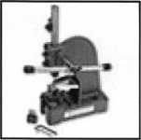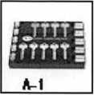

Stamping Plate - This tool is a Delrin  
plate used to hold the keys while stamping  
as well as holding the cores so they can be  
stamped as well.

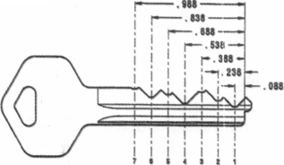

Dumping Block - This item is a must for decoding cores.

It allows the user to de-cap individual chambers and remove  
each pin stack while keeping the pins in order.

Combinating Tray - A handy little item for holding cores  
that are in the pinning stage of completion. The tray does  
not allow the cores to roll or fall over dumping the pins you  
have already placed in them.

Capping Pin - This is used in conjunction with the cap-  
ping block to seat the caps in the chambers.

Ejector Pin - This item looks a little  
like a 1/16" pin punch on a small han-  
dle. It is used to manually remove the  
chamber caps and pins from a core. It is  
also useful in unbinding master pins that  
sometimes get a little crossways in the  
chambers when loading. ( I'm not sure

crossways is a real term but the Southerner in me had to be  
subdued to not use "catawampus" instead)

Pinning Kits - Since these locks use pins that are not the same diameter as standard pin tumbler cylinders, you will certainly need pin kits for SFIC. Depending on the systems you encounter you may need as many as 3; one for each system A2, A3 and A4.

Key Punch - Though many key machines will cut these types of key, often you will find that the jaws of your stan­dard duplicator or code cutting machine will not hold these keys correctly and therefore will not cut a clean key. If you do a lot of SFIC work, you will want a specific code punch for your keys. Commonly referred to as a "Blue Punch" the version made by Pro-Lok is very reliable and economical. These machines are designed to cut one specific type of key and therefore the spacing and depths are set at the fac­tory. They make a very clean accurate key. These units also have a built in key gauge for gauging a pre-existing key. Ilco makes a unit called the Exacta and A-l has its Pak-A- Punch which also dodoes a nice job on these keys.

Various standard tools - tweezers, picks, files, etc.

ARTICLE BY JIM HANCOCK, CPL

Technical Editors note: Here are excerpts from the ALOA Professional Locksmith Dictionary that apply to terms used in this article:

control chamber

n. in an interchangeable or removable core, any chamber which has a control shear line, which is different from the operating shear line

control cut

n. any bitting which operates the retaining device of an inter­changeable or removable core

control dimension

n. in certain interchangeable or removable cores, the distance between the operating shear line and the control shear line, expressed either in units of the increment or as a measurement

control key

n. 1. a key whose only purpose is to remove and/or install an interchangeable or removable core, 2. a bypass key used to operate and/or reset some combination type locks, 3. a key which allows disassembly of some removable cylinder locks

control lug

n. that part of an interchangeable or removable core-retaining device which locks the core into its housing

control number

n. a number used to calculate the size of the build-up pin when; (a) the sizes of bottom and master pins are known, or (b) the bitting depths of all operating keys are known

control shear line

n. the shear line which allows operation of the control lug of an interchangeable or removable core

control sleeve

n. the part of an interchangeable or removable core retaining device which surrounds the plug

pin stack

n. all the tumblers in a given pin chamber, see also "pin stack height"

pin stack height

n. the measurement of a pin stack, often expressed in units of the lock manufacturer's increment or as an actual dimension

top pin

n. usually a cylindrical shaped tumbler, usually flat on both ends and installed directly under the spring in the pin stack

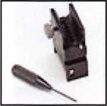

Tune in next month for the second part  
will deal with the math and techniques  
and core removal.

of this article that for control pinning

Keynotes • September 2005

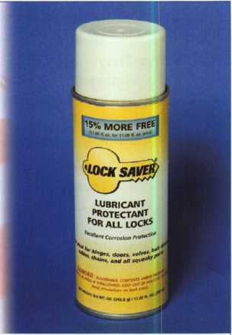

World's Finest Synthetic Lubricant

Long Lasting Lubrication & Protection

MADE IN THE USA

Environmentally Safe, Non-Toxic Will Not Gum Up or Clog Up For All Lock & Key Combinations

MI-SIMF

Mil-Comm Products Company, Inc.

* Will Not Attract Dirt, Water or Debris
* Works Well in All Climates
* Temperature Range: -65°F to +450°F

TOLL FREE: 800.743.4518

Visit Our New Website: [www.mil-comm.com](http://www.mil-comm.com)

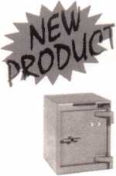

FROM A & B  
SAFE CORP.

A & B Chest  
Model WS-0

Equipped with dual key,  
combination or  
electronic locking  
slot optional

A & B SAFE CORPORATION

171 S. Delsea Dr.

Glassboro, NJ 08028-6237

856-863-1186 Fax 856-863-1208

CALL C. 1-800-355-6322 For More s „ Information '

I

<b

O

Professional Business Products

We offer lower prices on standard and custom  
invoices/work orders, checks, business cards,  
repair tags, key tags, magnets and much more.  
Call today for our brochure and samples.

[www.pbp2000.com](http://www.pbp2000.com)

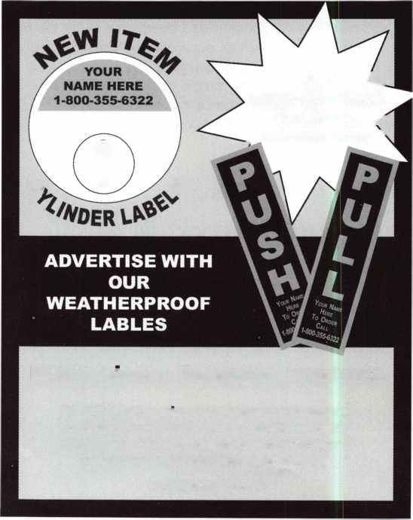

**THE LAST GREAT ★ ★★**

**MADE IN THE USA**

**RELOCKER:**

Independent

spring-loaded

relocker

**HINGES:**

Heavy duty, adjustable solid steel block hinges

**BODY & DOOR:**

Thick outer and  
inner steel plates  
encase high  
density fire barrier  
material.

**BOLTWORK:**

3-way boltwork with 6 massive 1” diameter solid steel bolts

**LOCK:**

UL-listed high security Group II combination lock. Drill-resistant steel hardplate.

**ADDITIONAL**

**FEATURES**

Light gray finish Adjustable shelving Mounted on 4 rubber feet (removable). Pre­drilled boltdown hole.

**OPTIONS**

Electronic digital pushbutton locks. Additional shelving available.

**UL Class 350 1 Hour Fire & Impact Rated - 3 Sizes Available**

**DEFIANT SAFE COMPANY Dallas, Texas**

PATRIOT

1**-**800**-**225-2984

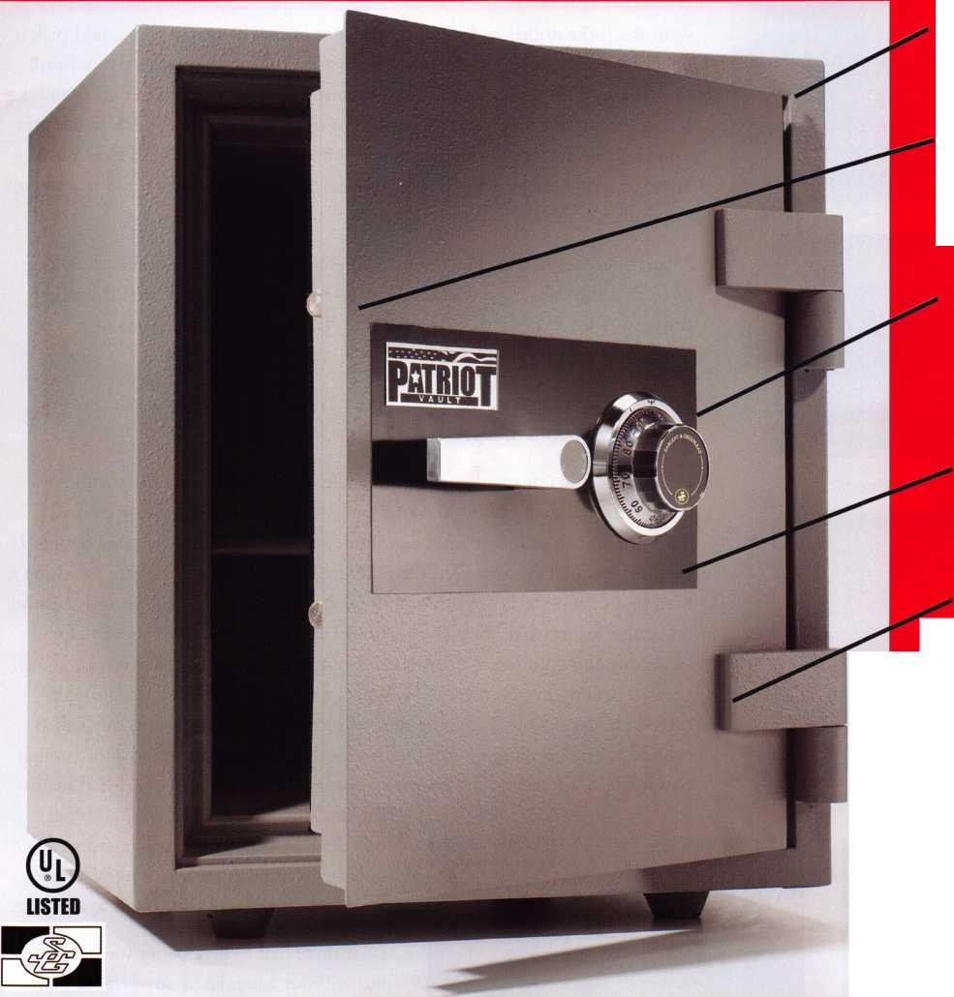

Safe Cracking and Snow Chains in July

By Greg Perry, CML, CPS

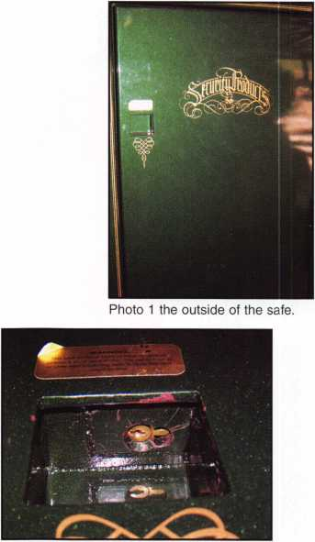

Some jobs are easy. Others are only fun when you look back on them. This job  
required ingenuity, skill, determination and a little luck to get the safe open.

The safe, manufactured by Security Products Inc. of Texas, uses two modified  
cylinders from American 2000 locks. In the beginning, the customer did not  
want the locks drilled and spent time trying to find someone who could pick it  
open. I was third man on the job. The first technician wanted to try and drill  
the cylinders but the factory advised against it. Next, he called our shop and we  
sent over our best lock picker (No, it’s not me.), David Moen, CRL to attempt  
to pick open the safe. David is a pretty good lock picker but after a couple of  
hours of trying, he gave up as the cylinders are recessed in a box and it is almost  
impossible to get a tension wrench or pick into the tight space.

A year after David tried picking the cylinders the customer called back, asking  
us to drill the safe. No one else wanted to touch it. Confident that it would  
drill easy, I asked my girls to go with me. The customer lives on a ranch with  
horses and my girls love horses.

I figured it would take a couple of hours to open and repair the safe. No such  
luck! I spent over 6 hours working on this safe.

Photo 2 is looking up into the lock box. There

is not enough room for an angle drill. I had very little information about this safe. I believed it used the standard

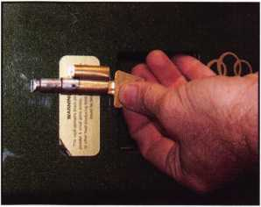

Photo 3 is an American 2000 cylinder on the face of the door showing the location of the cylinder in the safe. The first hole I drilled was a little to the side and above the cylin­der connection for a scope hole.

cylinder from American 2000 round body locks. A different customer, had  
once brought in cylinders from a gun safe that sounded like the same design. I  
checked and luckily, they used the 2000 cylinder. I attacked the safe assuming it  
used that cylinder. My target was a little above the end of the plug and slightly  
off-center for the first hole. The customer described a bolt that moved after  
unlocking the cylinders. I questioned it but, not having anything else to go on,

I feared drilling in case there was, indeed, a bolt that moved. I was also con-  
cerned about possibly damaging the roll pins that normally retain the locked  
cylinder. I tried drilling by hand with a cordless drill but there was not enough  
power. Next, I freehand drilled with a corded drill. After an hour, I had made

the first hole through the door and lock

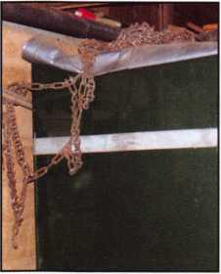

Photo 4 shows how I rigged a large digging or pry bar behind the safe and used my snow chains to extend the length of the chain out to the front of the safe.

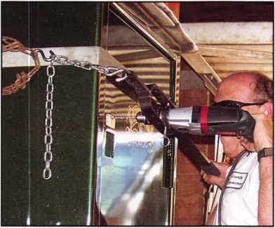

Photo 5 shows the lever rig set up in action.

bolt. The first hole gave me a good peek  
hole but I couldn’t see anything of value  
and the bolt was still connected to the plug.

I felt there had to be a better way to drill  
but without a handle or anything to grab  
the face of the safe a lever rig, I was in a real  
pickle. Or was I? I contemplated welding an  
eye to the front of the safe but I wanted to  
protect the nice paint job.

|  |  |  |
| --- | --- | --- |
|  |  |  |
| 1 \ i |  |  |

*

fverV

bodV it... You **MIGHT TAKE**

IT HOME!

One Lucky Member Attendee at ALOA  
2006 is going home with this gorgeous  
mint-condition 1956 Ford Thunderbird.

A ticket will be given to each ALOA  
Member who registers and attends the  
show. Someone has to win it, and it  
might as well be YOU!

(Must be present to win. Exhibitors,  
Employees. Family Members of Employees, and  
nonmembers **are not** eligible for this door prize.)

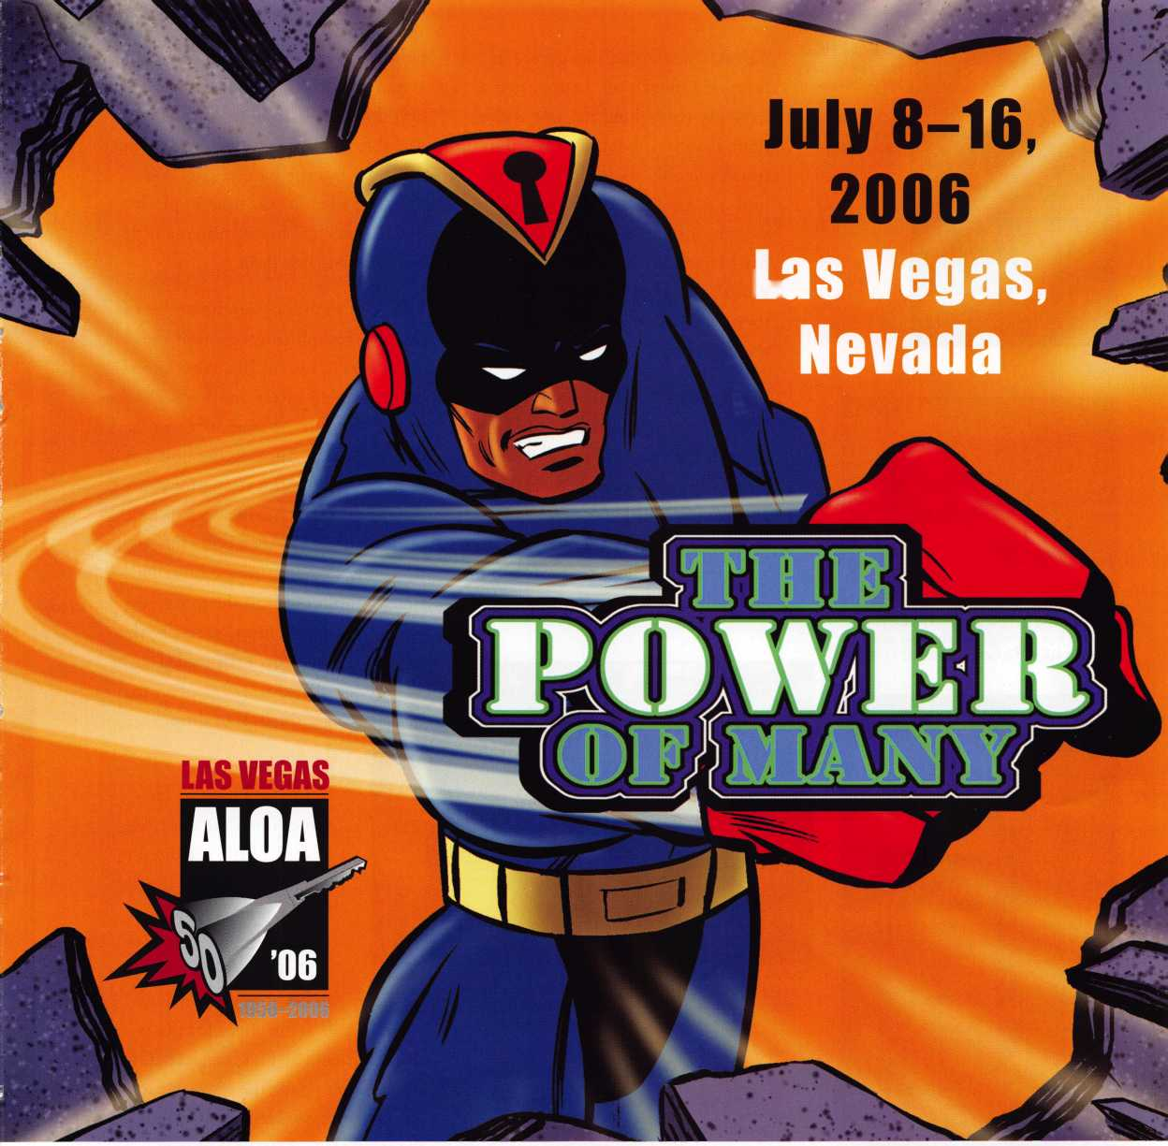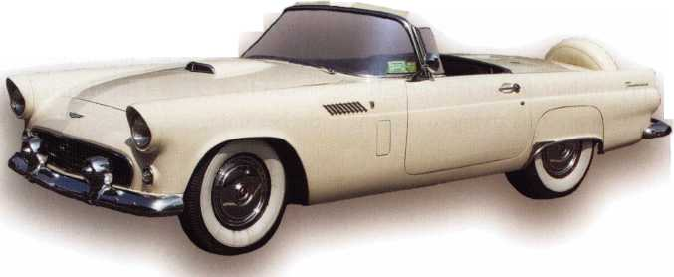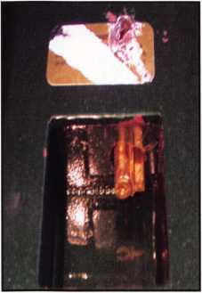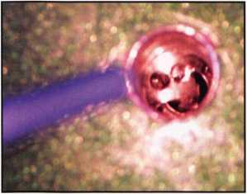

Photos 7 and 8 show the drilled hole, first with the bolt partially spun and next with it

Photo 11 shows the back side of the lock box. The two hole is above the main box.

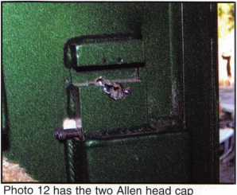

screws backed out to allow the cylinder to come out.

Photo 6 is after I was able to push the cylinder down and out of the way for the bolt to drop. This is the same view as photo 2.

The safe was stored in a garage in front of a block wall. I supported a large pry bar behind the safe at the right elevation. Looking around in my truck, the only spare chain I could find was my tire chains. I looped a section of the tire chains around the pry bar and hooked it to the chains near the front of the safe. “Now”, I thought “I can get some leverage on this baby!”

It was time to drill hole number two.

I drilled it a little off center and aimed towards the center of the end of the plug. Using my modified perch, I was able to drill a little faster for hole number two. Once the bolt was sepa­rated from the plug, I was able to pry and pull the cylinder housing out of

Photo 10 shows both my daugh­ters Michelle and Nicole in the traditional Ken Foo pose after the door is open.

the safe. Unfortunately, it would not come out of the safe because it is retained by a setscrew. (In hindsight, I might have tried to remove the cylin­der and decode it. This might have saved drilling for the second cylinder.)

For the most difficult part, I needed to turn the bolt exactly 90 degrees and pry the bolt down. This sounds easy but in practice, trying to turn the

bolt over one-inch deep into the safe is quite difficult. I finally got the top bolt down after an hour of trying. I was able to force it to turn with some difficulty but the hardest part was deciding when it was time to pry it down. Since the holes created a little burr it didn’t just drop.

I decided to drill down the center of the plug to bolt connection of the lower lock. This cut the connection between them nicely and I was quick­ly able to push the cylinder down and out of the way. Turning the bolt was a different story. After trying for some time, I decided to drill a fourth hole on the side of the lock bolt. Through this hole, I could turn the bolt. This time, I could not find the exact 90- degree location to pry the

bolt down. Instead, I turned it 270-degrees to get the bolt to drop.

Once the safe was unlocked I had the cus­tomer open the door. He looked a little surprised

I

when he didn’t see the  
bolts he remembered.  
Instead, the safe has two  
1/2” thick tabs welded to  
the side wall. They have  
holes in them for the bolts

to go through, as I had suspected. I  
started looking for the setscrews to  
remove the cylinders. They weren’t on  
the inside face. Instead, Security  
Products Inc. had modified the cylin-  
der bible. The tops had been cut away  
on both sides almost to the end of the  
cylinders. They used two Allen head  
cap screws to retain the cylinders. I  
should have noticed this design from  
the beginning.

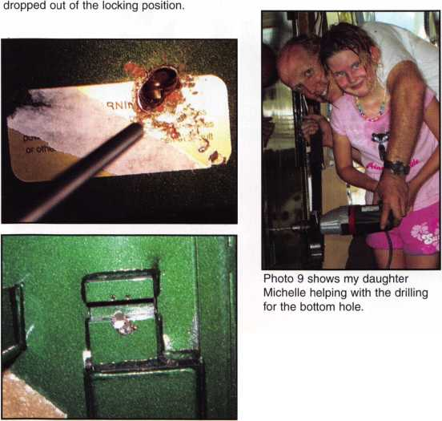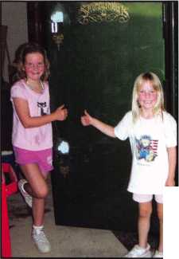

I inserted ball bearings in each of the holes and welded them in place, fill­ing the holes to the outside surface. Next, I puttied the areas with auto­body glazing putty to restore the smooth surface. After the putty dried, I lightly sanded the surface. This is the state in which I left the repair. I suggested to the customer that he could have an auto body shop repaint the safe to match the nice high gloss metallic finish or repaint it himself.

I brought the cylinders back to the shop and ordered a couple of new ones from American. The bad news was that they had redesigned the cylinders. “Now what?!”, I thought. I looked on our shelf and found two of the older-style cylinder 2000 locks. Swapping out the cylinders gave us the two cylinders we needed. A machinist who works for us made a fixture to hold the cylinders as he machined the sides to match the drilled ones.

This job obviously didn’t go as planned. But the important thing is that the safe was opened with mini­mal repairable damage and the cus­tomer is happy. In the future, the only thing I might do is make an attempt to remove the first cylinder and decode it. The worst-case sce­nario in doing that is that I may spend a little more time and end up drilling the door for the bottom lock anyway. I could also get the cylinder out, or at least get the first 4 or 5 cuts, and progress for the last cut or two. Hopefully I’ll never need to test my theory unless American goes back to the old design. The future of the this safe and it’s later repairs is unknown.

Photo 13 shows the locking tab from the safe body.

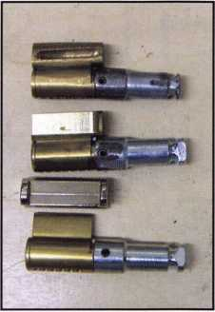

Photo 14 shows the three differ­ent styles of cylinders. The one on the top is the old style cylinder. If you ever need to open one of these safes you will need an old style cylinder to modify like the middle cylinder. The bottom cylin­der is the new style. It uses a standard cylinder with an addi­tional top that goes over the bible of the cylinder to retain it in the padlock.

New! Keedex Stainless Steel

Armored Door Loops

ALL

STAINLESS STEEL  
DESIGN

FLEXIBLE STAINLESS  
STEEL CONDUIT

COSTS NO MORE

**than most door**

LOOPS THAT HAVE  
PLASTIC END PIECES

AVAILABLE FROM YOUR  
KEEDEX DISTRIBUTOR **Call or write today**

for your free catalog!

Keedex, Inc.

12931 Shackelford Lane  
Garden Grove, CA 92841  
714-636-5657 • Fax: 714-636-5680  
e-mail: [info@keedex.com](mailto:info@keedex.com)

[www.keedex.com](http://www.keedex.com)

MADE IN U.S.A.

Keynotes • September 2005

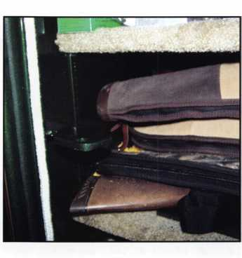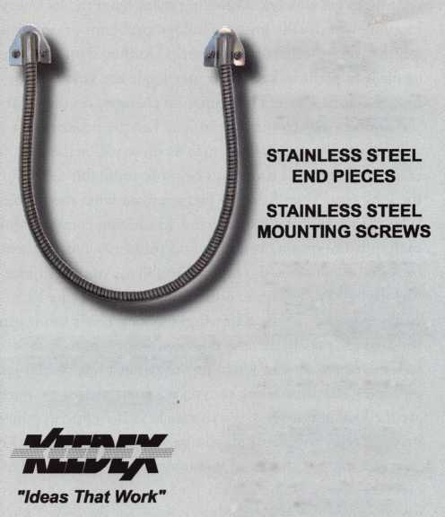

The Six Biggest Mistakes Made

How to Spot Business Killers in Action

By Jon B. Griswold, CML

I know what everyone thinks when I tell them how few mistakes I’ve made in my career. Only SIX mistakes in 25 years as a lock­smith?! I’ve made hundreds of other mistakes; however, they are all variations of these six, which I have named the Business Killers.

1. Failure to Look. Listen and Understand. Others call it

“jumping right in”. On every service call, have the customer show you the lock, demonstrate how they operate it, and tell you what they want done. Sounds simple, doesn’t it? Have you ever wasted time trying to find the lock the customer is talking about in a large building?

Have you ever found that the office has three doors, not two, as the customer had stated? It is wasted time to try and find the customer to get more information. With any luck, they have not gone to lunch, or are in a meeting, or that phone call that they’re on is not very long. I think it makes you look less professional when you have to hunt a customer down for little things like this. Demonstrating how they operate the lock is usually the most overlooked observation, yet one of the most important things to know before pro­ceeding to get to work. Watching them open the lock very carefully will usually uncover hidden problems or opportuni­ties for you in terms of more work. Do they slam the door or lift it to get it to latch? Do they jiggle the keys to get them to turn? On safe combination changes, do they dial the number slightly off or spin it so fast the numbers are just a blur? Simple observations such as these will make your job easier, save valuable time, and be more profitable for you in the long run. Then listen to them explain what the problem is before starting the task at hand. Gathering enough infor­mation is important. You may find problems and fix them, but they may not be the original problems your customer was having. For example, difficulty in operating the lock could mean any of the following: the lock needs lubricating, the keys are poorly cut, the door not hung properly or is warped, or has a worn latch, just to name a few. When your customer asks for a rekey, do you ask how many keys oper­ate the lock and if there is a master key? It’s surprising how many say no, and then call you back because someone’s key doesn’t work any more. It’s a common misconception that everyone has the same key for the lock. Never be afraid to ask questions before beginning to work on the lock. Don’t forget that the objective here is to determine the problem

and come up with a solution that solves said problem for the customer.

1. Taking shortcuts and not using quality hardware seems like two separate issues, but I think they are so closely related I group them together. I have learned from -first-hand experi­ence that poorly-executed shortcuts and substandard hard­ware will negatively affect your bottom line. Too many times we think we are doing the customer a favor by saving them a few dollars just to “make it work”. Do you think the cus­tomer will understand when the helpful repair breaks down? They will expect you to fix the problem immediately at no charge. Trying to explain yourself will only result in having your previous and future work called into question. If there is any question regarding the proper workings of a lock or cylinder, replace it. To take the shortcuts of filing, grinding, inverting, enlarging, or cutting usually results in unprofes­sional-looking work. I agree that there are times when this has to be done, but quality products should never be consid­ered as overpriced locks that can easily be replaced with something substandard. Quality hardware is an investment in your business. The use of quality products will reduce callbacks, have higher profit margins, and operate easier for the customer. My suggestion is to find a few product lines you like to work with that are reliable and readily available. This will allow you to service the majority of your cus­tomers. It will also reduce the amount of money that is tied up in inventory. Don’t make the mistake I made by trying to be everything to every customer. At one time, I had so much money tied up in inventory that my cash flow was affected, plus I carried more than a few inexpensive lines. This result­ed in many callbacks, upset clients, and additional unneces­sary work. I have since learned my lesson and upgraded on the quality of lock I offer my customers. When a customer has a broken lock from one of those home improvement centers I sell them one of my locks and explain the differ­ences between the two locks. Most customers agree to the products I recommend because I know the importance of the hardware features, benefits, and warranties in order to properly sell the product.
2. Sitting back and waiting for the business to come to you. One thing I learned early on was that the amount of energy expended equals the amount of business received. The most successful businesses promote themselves. Sell your self,

22

Keynotes • September 2005



products, and company to everyone you meet. Nothing is better than a face to face meeting. Being proactive ensures success. Relying solely on phonebook ads or direct mailings are passive tools we have little control over. Determine who your customers are and which area of your trade you’d like to specialize in. Make a list of contacts and set appointments for an initial meeting. Join an organization such as your local chamber of commerce or Knights of Columbus and attend their lunches or meetings. Meeting people from dif­ferent businesses is a good introduction for you to explain your services and why you are the right person for the job. Another option is to team up with an experienced represen­tative from a local manufacturer or distributor and jointly meet with potential clients. This can help in providing sup­port with your presentation of your company and be an “in” to getting more customers. This reminds me of when I was a sales rep for a New England wholesale locksmith company. I called on locksmiths for their business and it was tough at first. I was ignored, heard many complaints on high prices, the cost of delivery, and the headaches of refused merchan­dise. It made for a very interesting day indeed. Then there was that one customer who responded and placed an order, and it made all the negativity disappear. In fact I had the energy and excitement to try it again the next day! Good customers make it all worthwhile.

1. Hiring the first person who walks through the door. To be successful, qualified people must be hired who fit your busi­ness outlook and can be paid fairly. Some companies hire apprentices and train them on the job. Others like to hire trained locksmiths, possibly due to lack of adequate time and money for training. I know of companies who have done both with much success. It is equally important to have someone that not only fit in with your company, but also works well with your other employees. If you have a service-oriented company, hiring someone who works with minimal customer contact may not be a good fit. However, if you have work that requires that the locksmith move from job to job quickly, then this type of employee is for you. I have found that you need have a balance between the two. And you may have to pay more to retain this kind of employee, but it is well worth it. It is indeed less expensive to keep a good employee than it is to hire and train a new one.
2. Not learning the value of saying “no” every now and then. Many customers have learned to negotiate everything they purchase, such as terms, price, delivery, and time of day the work can be performed. Negotiating is acceptable, but you need to be willing to say no at any time. Many times terms are agreed upon just to have the work, with low margins, and quite possibly loosing money on the job. There are only two times I have found this concept successful. One is if you were to enter a new market, let’s say, access control, and you take the job so you can learn how to install and service the product. The other is doing work for an established cus­tomer, who wants a big job, or partial job performed at a discount rate. I recommend having the customer pay full price on the first installment and then apply the discount at the end of the job. In this way you don’t lose money and the customer will get the same great price at the completion of the entire job. Realistically, it is better to simply say no to these types of jobs and move on to more profitable work. If you are in a slow period, why not call on your clients and see if they need anything done, or stop by and say hello?

The downtime could also be utilized to clean and organize the shop and service vehicles, or draft a spreadsheet for upcoming work. You do not have to constantly be working unprofitable jobs in order to be successful.

1. Asking for payment from commercial customers. Commercial customers are used to being billed at the time of service, so it is usually no problem to receive payment from them when the service is completed. This is especially true for first-time customers and regular customers who are slow pays. If you have an established customer who pays on time and has a proven payment history, perhaps you feel comfortable in sending a bill for there are no worries that you will indeed be paid. Residential customer should always be billed COD only and never invoiced for work per­formed. For some locksmiths, getting payment is one of the hardest things to do, but it is worth it. Not getting paid is one of the greatest drags on your cash flow and will nega­tively affect your bottom line.

I am sure I am forgetting to mention more Business Killers, but I have found these six to be the root causes for many unpleasant situations. I wrote this to make you, the reader, think before you take action in hopes of saving you from losing money, valuable customers, and most importantly, your mind! Good luck!

Keynotes • September 2005

Long-Lasting Mortise Locks

By Eric Costley, CPL

It’s not a job that you wish for. It’s not quick, easy, or even enjoy-  
able until you can sit back and say, “I did that!” Ripping out old  
mortise locks and replacing them with new ones can be your  
worst nightmare, or give you your finest bragging rights. But  
before we dive in, let’s get our feet wet with a little background.

Before I went back to college, I worked a year or so in a textile  
mill in North Carolina. We had a colloquial expression that was  
often uttered...“getting called on the carpet.” This meant that you  
had to go to the office to see the boss. (The office was the only  
place with carpet. The rest of the flooring in the plant was made  
of either concrete or hardwood.) When I drove up to the high-  
rent district that spawned this call, I felt the same sinking feeling

in my stom-  
ach that I felt  
when I got  
“called on the  
carpet”. I felt  
I was out of  
my league.

The house in  
question was  
huge, and well  
maintained. I  
had to dodge  
the yard  
workers, park  
on the street,  
and wait

about 3 minutes from the time I rang the doorbell until someone  
could make it to the door. There were 3 doors on the ground  
floor, all equipped with Reading mortise locks. Although they  
were all basically functional, the matron of the household wanted  
new locks. I went to each door, measuring the backset, trim  
dimensions, and distance between the pitcher handles and mor-  
tise cylinder. I suggested that she take an Emtek catalog and pick  
out something that she liked. Basically, she wanted the locks to  
match the decor and “feel” of this historic home. All I was con-  
cerned about was what would match the existing holes in the  
door, and whether or not she would be willing to shell out the  
large chunk of change that this job would entail.

A few days later, I e-mailed her a quote. She bit. I cringed.

The most important thing that I can tell you about ripping out  
old mortise locks and replacing them is to measure once, measure  
twice, measure 3 times and get a template for the new stuff  
before you install it! After all, this job represented not only a

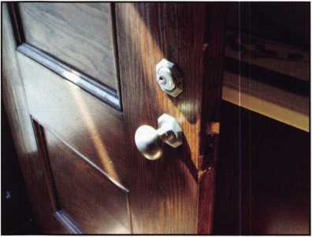

The rear door before we started. Note that the cylin-  
der is off center, since the set screw that should  
hold it in place is missing.

great deal of  
money, but  
also possible  
prestige with  
the neigh-  
bors, which  
might mean  
future jobs of  
equal or  
greater mon-  
etary gain. I  
don’t know  
anyone who  
enjoys trying  
to replace

obsolete mortise locks. Most of the time, we simply rip them  
out, put a wrap-around plate on the door and install modern  
locks. In this historic home, this, that was out of the question. It  
was like pulling teeth to get a template from the manufacturer,  
but finally it arrived. I returned to the house to compare the tem-  
plate to the existing hardware. Once I was convinced that the  
desired locks would cover most of the trim holes, we ordered the  
hardware and set aside a day to install it.

Two of the doors had pitcher handles, while the third had only  
knobs. In addition, the size of the pitcher handles was different  
between the two doors.

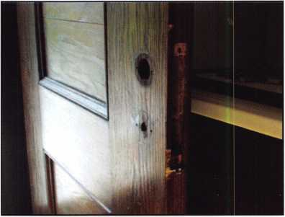

The rear door with the old Reading lock removed.

My pick for the replacements was the Emtek Cheyenne mortise  
lock in a “medium” bronze finish. (The medium bronze is pretty  
much the equivalent to a 10B finish, or oil-rubbed.) The nice  
thing about this particular product is the large trim plate which  
covers a multitude of existing holes. I ordered the longer pitcher  
handle for

the front  
door, and the  
shorter for  
the two other  
doors. For  
those of you  
who are unfa-  
miliar with  
the Emtek  
line, I can  
assure you

that Emtek is The 0|d removed, and the new mortise case

virtually of installed in the door. Note that the holes match

up pretty closely!

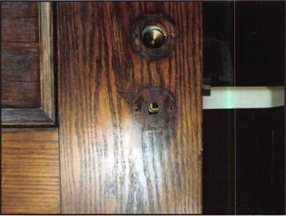

Keynotes • September 2005

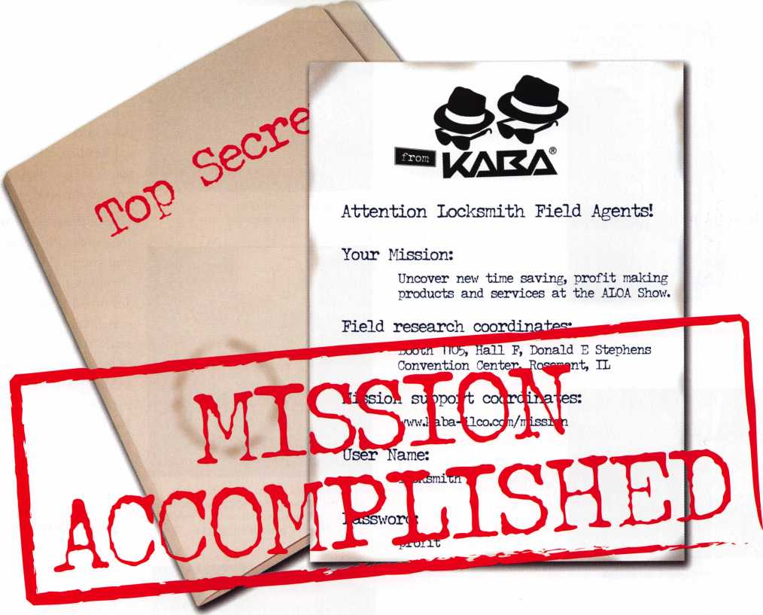

For your eyes only:

Kaba Access Control, Kaba Mas  
and ILCO recruited many new  
field agents at this year's ALOA  
convention.

Visitors uncovered a vast array of  
Kaba products designed to save  
time, simplify work and improve  
operating profit.

Log on to our Mission Support Site  
for details on what they uncovered.

Discover how

“Lectrobolt” is revolutionizing electronic lock installation.

KAELflk

IVIAS Discover how Auditcon 2 sets new standards in the safe lock industry.

Hnn Find out what it

takes to outfit your mobile lockshop for the 21st century.

**[www.kaba-ilco.com/mission](http://www.kaba-ilco.com/mission)**



TOTAL ACCESS

**Kaba Americas**

[www.kaba-ilco.com](http://www.kaba-ilco.com)

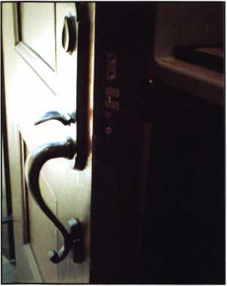

The finished product installed.

Now doesn't that look more impressive  
than the original hardware?

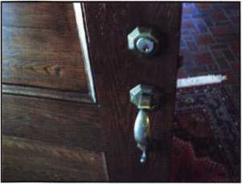

The front door before we started.

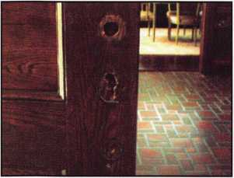

A view of the exterior of the door  
with the existing hardware removed and a  
bit of re-drilling.

the same quality as Baldwin hardware, only at a fraction of the price. In addition, distributors do not stock the hard­ware, as each lock is “cus­tom tailored” for trim and finish which allows the customer to personal­ize the lock to their own tastes. (You can contact Emtek at emtekprod- ucts.com.) Their line of “retro” products, (includ­ing painted porcelain knobs designed to fit in a standard 160 or 161 prep,)

is impressive.

When the locks arrived, Mark Fuller CML, my esteemed employer, and I headed out to tackle the task. We headed for the back door first because we decided that if a mis­take was to be made, it would be better to make it in a less-obvious place. As it turned out, the mortise case fit almost perfectly in the existing door cutout. The face of the lock required some further mortising, but everything else went quite smoothly. After working together on this door, we parted ways. I went to the front door, and Mark went to the side door.

One of the things that I mentioned earlier was measuring. I must reiterate that, and if you need to stamp it on your forehead backwards so that you can see it in the mirror, do so. Despite having measured each of these doors at least three times before ordering the hardware, I screwed up. First of all, I accidently ordered an incorrectly-handed lock. Emtek specifies that locks are handed and should be ordered that way. I really don’t know why, unless they don’t want incompetent people getting into the mortise case, because luckily, the locks are 100% field reversible. (Whew. First problem solved!) My second mistake revolved around the front door. Somehow, I failed to realize that this door

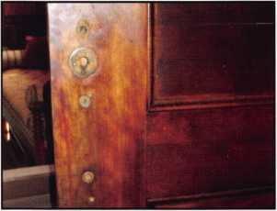

The interior side of the front door  
after re-drilling.

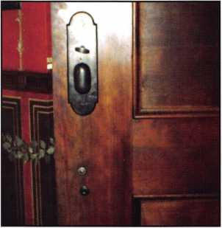

The finished interior of the front door.  
Note the off-center bolt which was the only  
glitch in the entire retrofit, which is invisible  
from the exterior of the door.

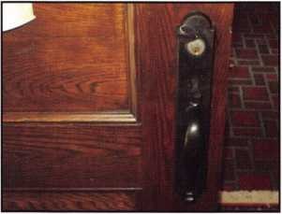

The exterior of the semi-finished front  
door. The old cylinder was temporarily  
installed, (even though it was not long  
enough to actually operate the lock.)

Thanks to Lloyd Seliber of Dorma,  
a new cylinder was installed days later!



|  |  |
| --- | --- |
| irrr | • — |
| 1r- €» €•' | m |
|  | • <■* r |
| W lr fc- | e-> €> c |
| f» • 0 | f fy c |
| 9^9 | r % r |

A typical Emtek display, showing the  
wide variety of "retro" products that  
they manufacture.

was two inches (or more,) thick. The Emtek trim extends about another 3/8 of an inch from the face of the door, and even the origi­nal Reading cylinder wasn’t long enough to operate the lock.

One of the perks of writ­ing articles for Keynotes is that you tend to make friends in the industry. I am proud to say that my e-mail address book reads like a “who’s who” of locksmithing. (Although he has passed, I still have A.J.

Hoffman’s email address firmly locked in, and until I get alzheimer’s and forget who he is, I plan to keep it there out of respect.) Over the past few months, I have been corresponding with Lloyd Seliber about some quirks in masterkeying. Lloyd spent some time working with Schlage, and now he works for Dorma, of Reams town,

Pennsylvania.

When he initially got in contact with me, I said that I didn’t even know that Dorma had a keying records department. Evidently, Dorma does more business overseas than they do here in the USA. (Hey, support America! Buy american- made products!) Dorma manufactures a wide range of products includ­ing lever sets, mortise locks, panic hardware, access control equipment, revolving doors, and much, much more. (For



Keynotes • September 2005

more info on their products, visit them online at [www.dorma.com/usa](http://www.dorma.com/usa).)

Emtek products come equipped with a Schlage “C” keyway. Since I knew that Lloyd had contacts there, I immediately e- mailed an S.O.S. A day or so later, I received a 1 3/4" mortise cylinder, dark bronze, SC-1 keyway from Dorma. (Thank you, Lloyd!) The job was completed, the check was received, and I’m as proud as a peacock of the finished job! The only hole from the pre­existing lock that wasn’t covered by the new lock was the bolt-through hole for the bot­tom of the old pitcher handle, (on the interi­or of the door). I simply used the old bolt through and secured it with a nut on the other side underneath the new trim plate. (This was on the front door... the other two doors were virtually perfect.)

No, we haven’t been swamped with more orders from this high-class neighborhood. However, when something unusual is needed from this area, we inevitably get a call or visit. Probably one of the reasons we don’t do that much work in the area is that the antique locks are still perfectly functional. One of the nice things about mortise locks, (assuming they are of decent quality,) is that they tend to outlive the original owner. I can’t even count the number of times that I’ve told a homeowner that a quality replace­ment for their antique mortise lock would probably run between $300 to $400 dollars for the lock alone, let alone the charge for the installation. I’ve heard that surprised gasp over and over again!

Next month we’ll be tackling installation of a mortise lock in a fire door that dates back to the 1800's . You’ll be surprised at what we picked and why! Lor starters, the door itself is 2 3/8 inches thick... and the complications just keep coming!

Until then, visit Emtek and Dorma’s web­sites, and pick yourself out something nice.

New Lower Prices  
on Select Floor,  
Fire, CBF and  
Depository Safes!

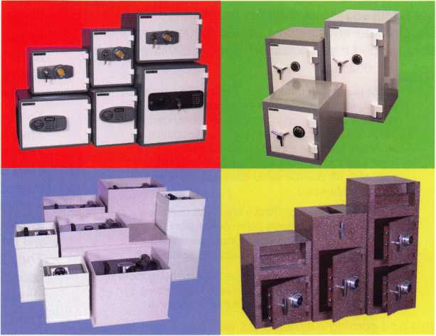

Beginning May 1st, you can find substantial savings on our most popular models. Adesco continues to lead the way in offering superior quality at a better price. I invite you to call your local distributor and visit our website for your new lower price.

manufacturing co.

Call your Adesco distributor today.

(800) 694-9340 • [www.adesco.com](http://www.adesco.com) • [safes@adesco.com](mailto:safes@adesco.com)

Keynotes • September 2005

2



Bylaws Changes

**Update**

COMPANY MEMBERSHIP

The membership of ALOA approved, by overwhelming majority, seven bylaws changes this summer. Three of these changes substantially altered the requirements for membership in the association. Specifically, they estab­lished the following:

Probationary Membership: There will no longer be an “Apprentice” member. A person who has not achieved a professional designation recognized by ALOA will not be allowed to join the association as an Active Member. Probationary members will have three years to achieve a designation. Probationary members will pay the same dues and assessments as Active Members.

Active Membership: Active Members must now have a recognized professional designation. Every three years an active member must meet specified educational requirements to maintain membership.

Company Membership: Companies employing more than one member may elect a single membership that will provide limited benefits to multiple members.

In this and coming Keynotes, as well as on our web site, [www.aloa.org](http://www.aloa.org), the details of these changes will be explained. Because companies will have to make a deci­sion about membership before the end of the year, this first article is about the Company Membership.

Owners of larger businesses would often like to have all, or most, of their locksmiths become members of ALOA. If the owner is paying for the membership, this can be expensive. In addition, because the membership “belongs” to the employee, the owner may be paying, at times, for someone who has quit or been fired. On the other hand, ALOA would like to have more members. ALOA would like to have more attendance at educational events and convention. The Company membership addresses these issues.

The dues for a Company Membership are $200 per year plus $50 for each employee that the owner would like to be a member. At current membership rates, there will be no significant savings to the company until there are at least two employee members. Two individual active member­ships @ $130 = $260. A Company Membership with one employee is $200 + $50 = $250. The difference is only $10. However, three individual active memberships @

$130 = $390. A Company Membership with two employ­ees (three people) is $200 + 50 + 50 = $300. This is a sav­

ings of $90. The more employee memberships there are under the Company Membership, the greater the savings.

At this time, there is also a $25 legislative assessment for each member. This assessment will apply to all members covered under the Company Membership. The savings per membership remains the same.

The benefits that the employee members get are limited. They will be entitled to “Member Rates” for ALOA events. They will not receive individual copies of Keynotes. One copy of Keynotes will be mailed only to the company address for every two employee members. Employee members do not have the right to vote. Only the “primary” member (usually the owner) will vote. Employee members will not have “member since” designations on badges.

They will not be eligible for Membership Pins. They will not count in the “census” used to establish the number of Directors per region.

The Company will “own” the membership. If an employee leaves the company, the membership can be transferred to a different, or new, employee. The company does not need to notify ALOA of the change. Keynotes for Employee Members is mailed only to the company address so address changes are not needed. ALOA only needs to know the identity of the Employee Member when that per­son registers for an ALOA sponsored event. This will allow that person to get member rates and allow ALOA to record an individual membership number to track education, etc.

Any individual member who is working for a company can, of course, elect to retain his individual membership or establish individual membership. A Company may continue to pay for individual memberships. The Company Membership does not eliminate any of the current bene­fits or options of the individual membership. It adds a way for companies to have employees become members at a reasonable cost. In the long run this may increase our strength as an association and boost attendance at many of the ALOA sponsored events.

An application for Company Membership will be mailed with the dues bill this fall. Owners or managers can elect at that time which kind of membership(s) they would like to have.

m

Keynotes • September 2005

***colon tkod***

*Spnm*

*to hk...*

Prevents Surreptitious Entry at Airports.

Know when your bag has been searched by a TSA agent or violated by an unknown person.

*ako aoaiiabk:*

Black Fire Engine Red

Pewter Purple Grape

Bright Nickel Construction Orange Brass Plated Cobalt Blue Hot Pink

**SearchAlert®**



Recognized by the TSA

Security Window

o lock has been opened o lock not opened

**TRAVEL SENTRY**

CERTIFIED

c*£L*

301 West Hintz Road • Wheeling, IL 60090

Security Products 800.733.8588 • Fax: 847.537**.1** 88**1** • **[www.cclsecurity.com](http://www.cclsecurity.com)**

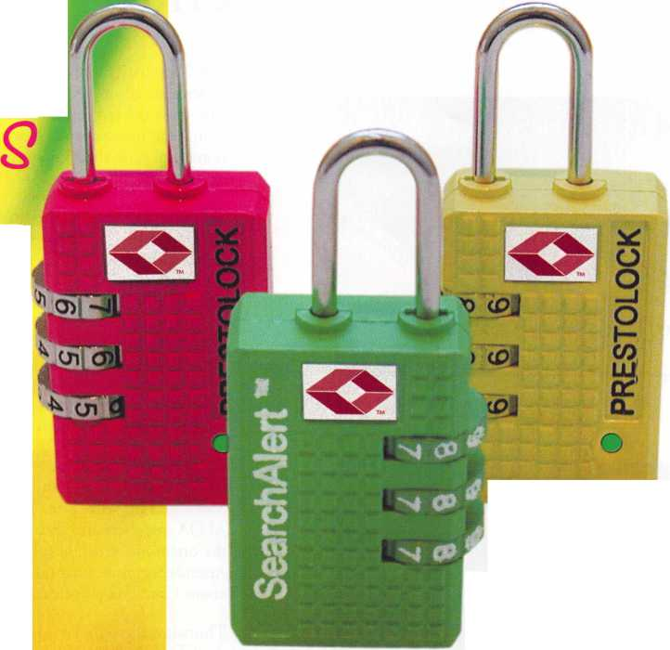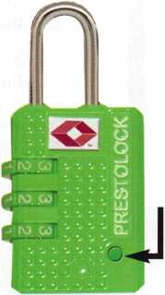

Baby, Aren’t We Glad We Went?

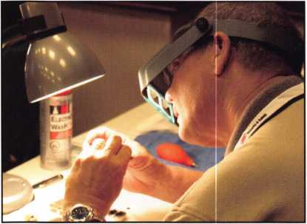

An average of 300 students attended  
ACE classes each day.

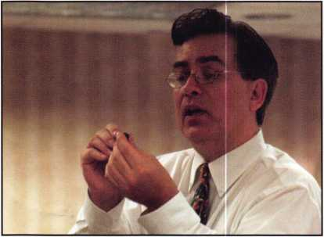

ALOA provided 658 hours of professional instruction.

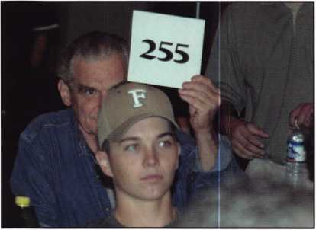

Over $45,000.00 was raised for the  
ALOA Scholarship Foundation

3,500 Security Professionals from around the world traveled to  
Rosemont, IL in July for the ALOA Convention and Security Expo.  
The show offered top-notch workshops and classes, an expo and  
more than one surprise. As always, the show helped security profes-  
sionals increase their knowledge base and open the doors to a bright  
new future.

With a total of 4o full-day instructors and 102 classes and work-  
shops, ALOA Continuing Education set the standard in security  
training. With 76 unique classes, many attendees commented on the  
great variety of options. In every session, attendees were pleased to  
find sensible solutions to real-world problems.

Networking opportunities were everywhere. From the classes, to  
lunches, to social events, old friends and new gathered to share the  
latest in security technology. Partnerships were formed and creativity  
flourished in the fun and professional atmosphere that can only be  
found at the ALOA Convention and Security Expo.

On Wednesday, attendees set out early for the Architectural River  
Cruise. Among the attendees were ALOA’s new President, Robert  
Mock and his wife, Dee. The personable, Mr. Mock chatted with  
ALOA members and discussed his vision for a bright new future of  
the organization while enjoying lovely weather on the river.

Attendees commented on the beauty of the city and learned much  
about Chicago’s rich history.

Thursday, the popular ALOA Open Golf Tournament was held at  
the Chalet Hills Golf Club. Golfers enjoyed their day in the sun with  
proceeds benefitting the ALOA Scholarship Foundation. Scores were:

Ron Smuck Low Gross 79  
Paul Justen Low Handicap 65  
Dan Boadwine Low Net 72  
Frances Watanabe Low Net 72  
Virginia Newburg Low Gross 105

The Kick-Off Party and Live Auction sponsored by IR Security &  
Safety, Associated Locksmiths of America, Corporate Safe Specialists,  
and Silver Sales was once again a huge success. ALOA 2005  
Convention and Security Expo attendees were treated to an around-  
the-world buffet, cocktails and great deals on security products.

At the party, Ed Woods, CML, CPS presented retiring ACE  
Instructor, Jerome Andrews, CML, with a memento of thanks and  
gratitude in memory of the late, A.J. Hoffman, CML. Ed Woods  
said, “Jerome was my first, and favorite teacher. I also know how  
much A.J. meant to him.” He then presented Jerome with the A.J.  
Hoffman Memorial Best lock. The lock, one of only 100 made, was

engraved in memory of the much-loved

**RL0R 2005**

Sweet Home Chicago

Hoffman.

In an emotional speech, Jerome Andrews stated, “ A.J. Hoffman and I grew up together. We worked together in the same lock shop. There’s hardly a day that goes by that something does­n’t happen to remind me of him.”



Keynotes • September 2005

**NOW EDGE™ KEY CONTROL KEEPS YOUR CUSTOMERS COMING BACK.**

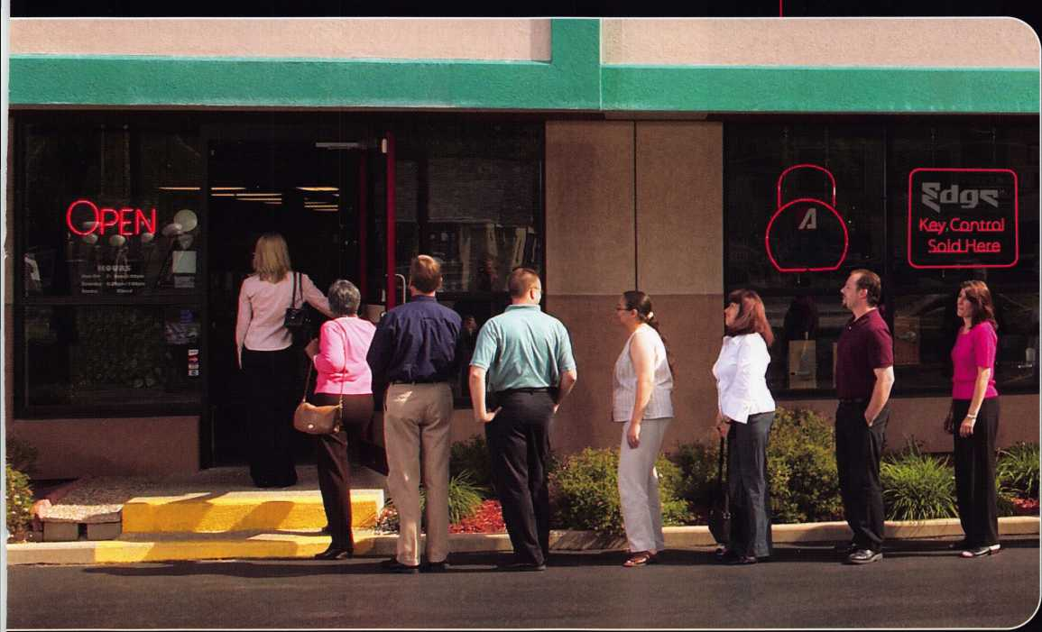

*Introducing Edge™ key control:  
the patent-pending system that*

*brings customers back to you — only you —  
again and again.*

What a great way to gain new customers and lock-in business for years to come!

Unlike costly "high security" systems, Edge lets you offer the kind of security a multitude of businesses need for door locks, padlocks — the works.

No one can duplicate keys without their consent. And no one can duplicate keys for them but you!



**Repeat business you can “own.”**

Edge key control prospects are everywhere — local

restaurants, strip malls, utilities,  
hospitals, municipalities, neigh-  
borhood stores, franchisees ...  
the list goes on.

Edge lets you deliver the

key-control security

they want — and  
can pay for. Year

after year after year.

Ask your distributor about  
Edge key control today.



' **NOW SERVING 1**



V J



*Edge fits American Lock® and Master Lock® commercial security products, as well as other makes.*



© 2005 American Lock Company, a Division of Master Lock Company

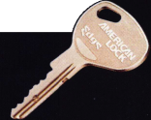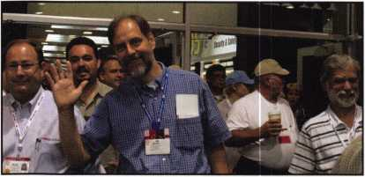

There were 2200 attendees.

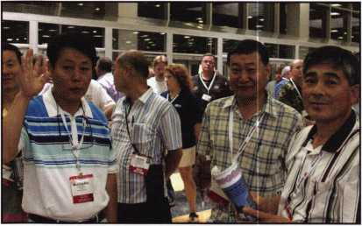

144 international attendees came from  
35 different countries.

Hail??

All 50 of the U.S. states were represented,  
including Puerto Rico.

Jerome went on to explain the importance of ALOA Continuing Education, stating that it is now time to “Pass the Torch” to past stu­dents who, thanks to the ACE program, are prepared to teach a new generation of locksmiths.

Jerome ended his speech in humor by holding up the memorial lock and stating, “I realize that this key is an undesirable combination.

A talented and exciting auctioneer assured that big-ticket auction items were gone in the blink of an eye. John Soderland scored a brand new Ford Van for $20,500.00 and the auction raised a whop­ping $32,247.50 for the ALOA Scholarship Foundation.

Friday morning, Robert Stafford, CML and David Lowell, CML, CMST hosted the CML/Keynotes breakfast. Sitting at round tables, CML members along with Keynotes authors and staff introduced themselves and discussed the ALOA show, antique cars, real estate and the need for standardized accounting practices and finance training for locksmiths across America.

The ALOA Membership Meeting gave member attendees a chance to offer helpful suggestions for the future. Several members announced their thanks to the staff and volunteers for an outstand­ing show. Achievements of the past year and future goals were stated.

Reginald Moxley thanked his team for another great ASF Golf Tournament. Since it’s inception twenty years ago, the golf tourna­ment has raised over $250,000.00 to educate locksmiths in the field. Mr. Moxley announced the winners adding, “The students who are able to take classes via the ALOA Scholarship Foundation are the real winners.” A check for $13,000.00 from Assa Abloy Aftermarket Group was presented to then-President of the ALOA Scholarship Foundation, Donald Rule, CML. Finally, with much emotion, Mr. Moxley announced his retirement from the committee and passed the torch to Scott Henke, Bill Young, and Vince Forman. Bill Young accepted stating, “We have some pretty big shoes to fill. If we can do half the job these guys did over the years, it will be a big accomplish­ment.” A presentation of personalized golf-related gifts was then made by Charles W. Gibson, CAE to four core committee members in thanks for 20 years of hard work and dedication. They were also presented with Life Memberships in the Associated Locksmiths of America. (Learn more about the history of the ALOA Golf Tournament in the October issue of Keynotes.)

The Membership Meeting continued with an announcement of the June 2005 Election Results, (see the new ALOA Board members in the July/August 2005 issue of Keynotes. The first installment of Bylaws changes explanations can be found in this issue.) A motion was then made to destroy the ballots. After Don Rule, CML request­ed the numbered totals from the Presidential election, the motion passed.

Awards were given to those who have done outstanding work in the field of locksmithing.

David Lowell, CML, CMST presented the award for ACE Instructor of the Year. He thanked the instructors for giving up their free time to travel across the country. Adding, “several people have really dedicated their time and effort to the ACE program but one relatively new instructor really stood out.” A surprised and grateful J. Casey Camper approached the podium to accept his award amid the cheers of his colleagues. He stated, “I don’t know what to say. I am absolutely bowled over.”

Keynotes • September 2005

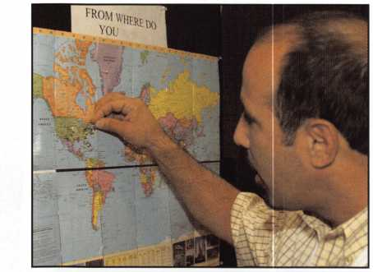

**uckcraR\***

**Surjs u • d**

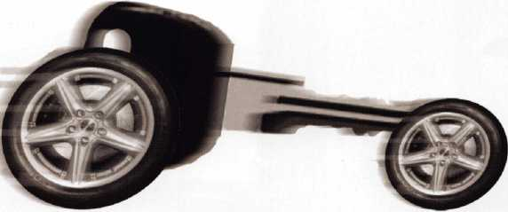

Get used to our market momentum! Lockcraft keeps your sales moving with our ever- expanding lineup of automotive locks, keys and service tools. Ask for all the OEM quality replacements you need -- for Ford, Daimler- Chrysler, Nissan, Honda, Toyota, and more. Yes, Lockcraft is still priced tight and right. Yes, Lockcraft still boasts 5-day/90%order fill. Yes, Lockcraft still offers the best profit opportunities in the business for you.

Surge ahead with Lockcraft!

VA **LOCKCRAFT**

2345 N. Central Avenue Brownsville, TX 78521 Phone: 965-838-2480 FAX 956-838-1796

In an emotional speech, David Lowell, CML, CMST also presented the Donald Davis Memorial Award to retiring ACE Instructors, Tom Nazziola and Jerome Andrews, CML for dedicated service to ALOA Continuing Education. In his acceptance speech, Tom said, “It’s been an honor and privilege to be of service to ALOA members all these years.”

As he looked at his plaque, Jerome Andrews humorously quipped, “I’m not disappearing. I’m not going away. I am going to take a breather. I may even write something! But there’s one thing I need you to do: 4, 16, 64, 256, 1024, 4096...”

Anticipation was also building for the Security Expo. Attendees crowded the lobby at the Donald E. Stephens Convention Center and a sea of anxious faces filled the room. Finally, the moment arrived. The ribbon was cut

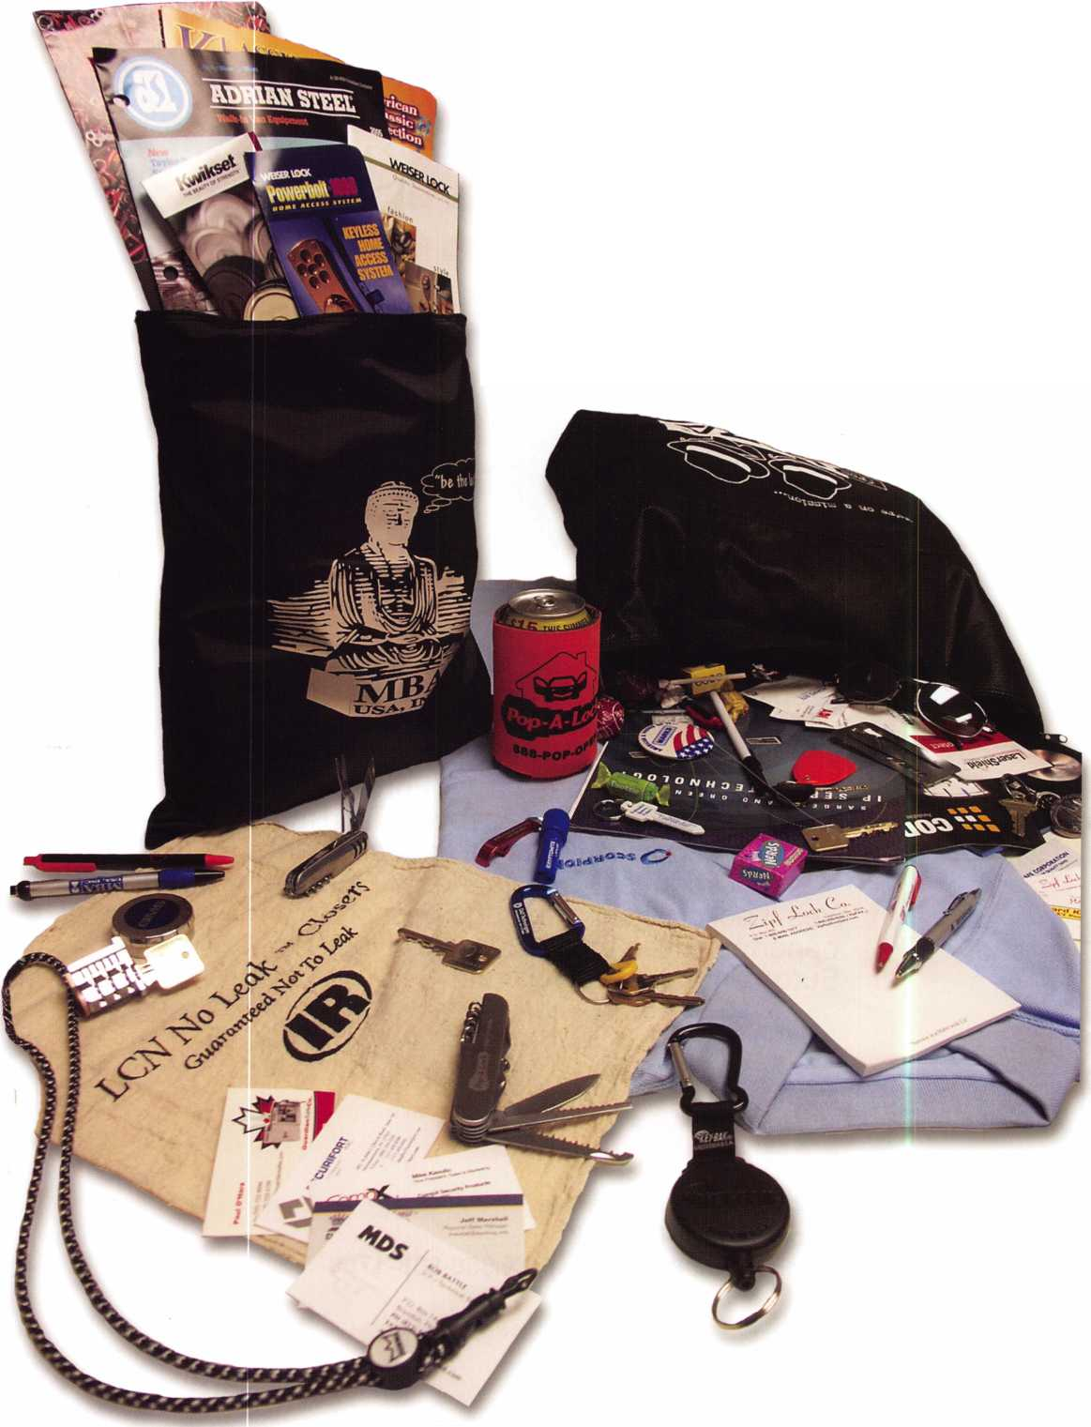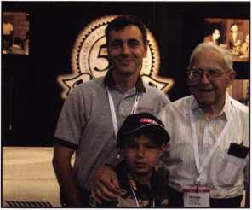

L—R: George Walters, II, ALOA Charter Member George Walters, Edison Walters

and attendees streamed onto the show floor. 170 exhibitors brought the most up-to- date equipment and manufactur­ers were on hand to answer ques­tions and display some of the best products in the industry.

A very popular booth was the ALOA 2006 display featur-  
ing ’’Marilyn Monroe” and a gorgeous 1956 Ford T-Bird to  
be given away at the 50th anniversary show. Visitors to the  
booth included ALOA charter member, George Walters  
and his family. Mr. Walters commented favorably on the  
growth of ALOA and the show, jokingly stating, “If I did-  
n’t approve, I wouldn’t be here!” When asked if he wanted  
to be a locksmith when he grew up, Mr. Walter’s young  
grandson, Edison said, “I’m still thinking about it.”

With great fan-  
fare, ALOA 2005  
exhibitor Alarm  
Lock, presented  
the keys to a  
brand new  
Harley-Davidson  
Sportsters® to two  
lucky contest par-  
ticipants. Jim  
“Yoke” Yocom  
from Earl’s

Locksmith Shop in Lansing, IL & Margaret Hopkins of  
Midwest Wholesale in Orlando, FL. were surprised and  
elated to win this great prize.

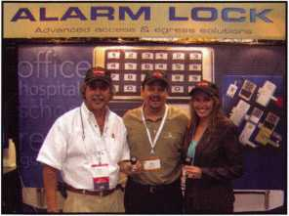

Saturday night, the

ALOA Gangster Night was held in the ballroom. Attendees got into the swing of things by dressing as

Mob Bosses and Flappers. ALOA President, Bob Mock treated everyone to his Godfather (“Bobfather”) impression and the Jim Mahannah Band, featuring Sarah Dease rocked the room with big band and jazz favorites. Partygoers enjoyed a 4-course meal, dancing, and friendly conversa­tion, twenties-style!

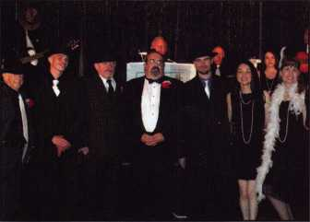

By all accounts, the ALOA 2005 Convention and Security Expo was a huge success. Be sure to view all of the pictures on line at [www.aloa.org](http://www.aloa.org) and make plans to attend ALOA 2006 in Las Vegas, Nevada.

Top Five Freebies

Every year, exhibitors bring thousands of promotional items to the ALOA Convention and Security Expo. If you missed the show, you missed out on so much, including these goodies! Here, we have rated our five favorites:

1.

Clever and Tasty—Clark securi­ty products gave visitors minia­ture Clark candy bars.

2.

Disco Yo Yo—HES gave away this groovy light-up yo yo, pro­viding attendees with a fun way to remember the HES brand.

3.

Major MBA Giveaway— Visitors to the MBA booth received info on great products, key-shaped bottle opener,s pick sets, pens and more!

4.

Pint-Sized Pins—Dorma show­ered attendees with thousands of tiny gold-tone lapel pins.

5.

Collectible Cars—What's the key code for this car? This limit­ed-edition toy sportscar from Assa Abloy/Akron Hardware collectible toy cars revved up our engines.

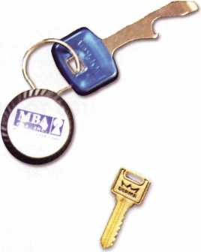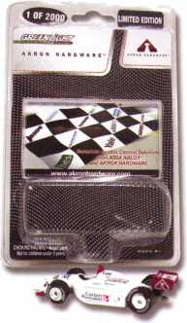

Keynotes • September 2005

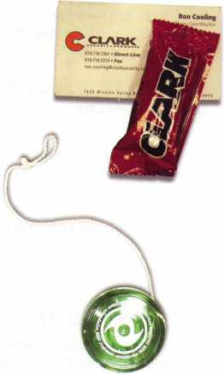

**Classifieds**

EMPLOYMENT

RELOCATE TO ALASKA "THE LAST FRONTIER"

Action Security, Inc. is a 42-year-old security company that is interested in hiring you. Its services include electronic security; bank/credit union security; wholesale products; hollow metal fabrication; contract hardware; retail security centers; and professional locksmith services. We have three retail locations and offer statewide service. We currently are in need of locksmiths, AHC's, CDC's, EHC's, electronics and bank technicians. Opportunity and profes­sional growth is encouraged. Ideal candidate must be neat in appearance, people orientated, self motivated and hard working. Applicants must possess a good driving record and pass drug testing. We will train the right candidate. Action offers full benefits package; competitive wages, medical insurance, paid vacation & sick days, continuous education, and profit sharing. Please send resume or email [info@actionsecurity.com](mailto:info@actionsecurity.com) if interested.

LOCKSMITH WANTED

Immediate opening at one of Columbus Ohio's largest locksmith companies. If you are a lock­smith with three years of commercial experience and want to work 8:30 to 5:00, come join our team! We are a full-service security center. Excellent benefits include 401 K, health insur­ance, paid vacation, sick leave, and continuing education. Contact Bill or Tim at Golden Bear Lock and Safe, Inc. 614-733-5625 fax 614- 733-0004, or email [goldenbearlock@cs.com](mailto:goldenbearlock@cs.com).

LOCKSMITH NEEDED

We are a 40-year-old rapidly growing company in need of experienced locksmiths. We provide all the tools, a brand new van, key machines, uniforms...the works. Salary is dependant

upon experience and skill, very competative wage and benefits package. Paid Vacation, 401k,

medical, cross training in our electronic security division and much more. We know how to treat good employees well. Please send resume or inquiry to [paulbrandon@lockguys.com](mailto:paulbrandon@lockguys.com) or call 253-839-3443

RELOCATE TO COLORFUL COLORADO

Buffalo Lock & Key is looking for an experienced locksmith to service commercial, residential, and automotive accounts. The ideal candidate is cus­tomer focused and a team player. We are Boulder's oldest and most reliable locksmith. Come join our team. We offer benefits and con­tinuing educational opportunities. Please contact Cindy at 303-494-0707 and fax resume to 303- 494-0706.

EXPERIENCED SERVICE TECHNICIAN

sought in established company in Central Illinois. Must have good driving record, positive work habits and be neat in appearance. Our compa­ny offers a competitive salary with an excellent benefit package - many EXTRAS. Mail or Fax resume to: Denny at Dave & Harry Locksmiths, Inc. 1 16 E. University Avenue, Champaign, IL 61820. Telephone: 217-352-5034 Fax: 217-352-3505.

WANTED TO BUY/SELL

SAFE DEPOSIT BOX LOCKS,

PARTS AND MORE

Wholesale prices. Reconditioned and new locks. All manufacturers; Diebold, Herring Hall & Marvin, llco, Lefebure, Mosler, S & G, Security Corp & Precision. Also available new replace­ment locks. We have a large stock of parts - doors, bond boxes, hinges, key blanks, full sec­tions and more. Call WBI (954) 484-2404

BUSINESS FOR SALE

Mom and Pop Locksmith, Glass and Screen Business for sale in Golden Valley, Arizona. Health forces retirement. Golden Valley is in fast growing Mohave County and located between Kingman, Arizona and Laughlin, Nevada. Our Dodge Ram Van and garage-shop are both well equipped. $65,000 plus in equipment and inventory is included in the asking price of $48,900. Home and property can be sold as a package deal with business. Home is 3 bed­room, 2 bath. Home and garage on 1.17 acres. Lot has enclosure, 2/3 fenced. All reasonable offers will be considered. Call 928-565-2294 or email at [lmburks@ctaz.com](mailto:lmburks@ctaz.com).

LOCKSMITH EQUIPMENT AND INVENTORY FOR SALE

Key Machines, key blanks, Inventory - prefer to sell complete, will consider offers on individual pieces. Call M.A. Box 432-448-2832 or 448-634-4808.

FOR SALE

Key Machines 1200 Blitz, HPC 3333, PCH 14,

1 1 Sets Tryout Keys, 16 Determinators Sets,

Pics, Entry Sets, Much More/Inventory

602 291 3500 - [chevieman@aol.com](mailto:chevieman@aol.com) - package

only.

FOR SALE

Locksmith Equipment and Inventory: Key Machines, key blanks, inventory - prefer to sell complete, will consider offers on individual pieces. Call M.A. Box 432-448-2832 or 448-634-4808.

BUSINESS FOR SALE

16 year old locksmith business located in Miami, FL. Large commercial account base. Serious inquires only. $375,000.

305 233-4447

Classified Advertising Policy

Classified advertising space is provided free of charge to ALOA members and for a fee of $2.00 per word, $40.00 minimum for non members. Classified ads may be used to advertise used merchandise and overstocked items for sale, "wanted to buy" items, business opportunities, employment opportunities/positions wanted and the like. Members or non members wishing to advertise services or new merchandise for sale may purchase a "Commercial Classified Ad" for a fee of $4.00 per word with a minimum of $ 100.00. Each ad will run for two issues. For blind boxes there is a $10.00 charge for members and non members. All ads must be submitted in writing to the Advertising Sales Department via fax at 817-645-7599 or through an email to [adsales@aloa.org](mailto:adsales@aloa.org) by the fifteenth of the month two months prior to issue date. ALOA reserves the right to refuse any classified adver­tisement that it deems inappropriate according to the stated purpose of the classified advertising section.

T.M.

*OPERATOR SAFETY*

Injuries can be virtually eliminated. Ultra Lift does the lift-  
ing so that operator effort required to complete a move is  
minimized. Heavy loads are broken back with ease. The  
operator stays in control by using a combination of motor  
power, balance and leverage in every phase of a move.

*REDUCE LABOR COSTS*

Fewer people are required for any move with Ultra Lift.  
Manpower can be scheduled more productively. Labor  
savings often pay for the Ultra Lift in one month.

*ELIMINATE DAMAGE*

Loads are broken back, set down and moved under power  
with maximum leverage and operator control. Gentle  
handling eliminates bumps, bounces and damage to the  
load and premises.

*INCREASE PROFITS*

Increased operator safety, reduced labor cost and elimina-  
tion of damage to the load and premises all contribute to  
significant increases in profits.

FOR LITERATURE, VIDEO OR ON-SITE  
DEMONSTRATION, WRITE OR CALL:

ULTRA LIFT supplies the power - so you don't have  
to. One person can safely and easily handle loads  
that usually require 2 or 3 people, even up or down  
stairs. Two people can handle most safes to 1500  
pounds. If safety is your concern, ULTRA LIFT is the  
best move you'll ever make!

ULTRA LIFT CORPORATION

475 STOCKTON AVENUE, UNIT E  
SAN JOSE, CA 95126  
800-346-3057  
408-287-9400  
FAX 408-297-1199  
E-mail: [info@uItraIift.com](mailto:info@uItraIift.com)  
[www.ultralift.com](http://www.ultralift.com)

U.S. PATENT 4.570.953

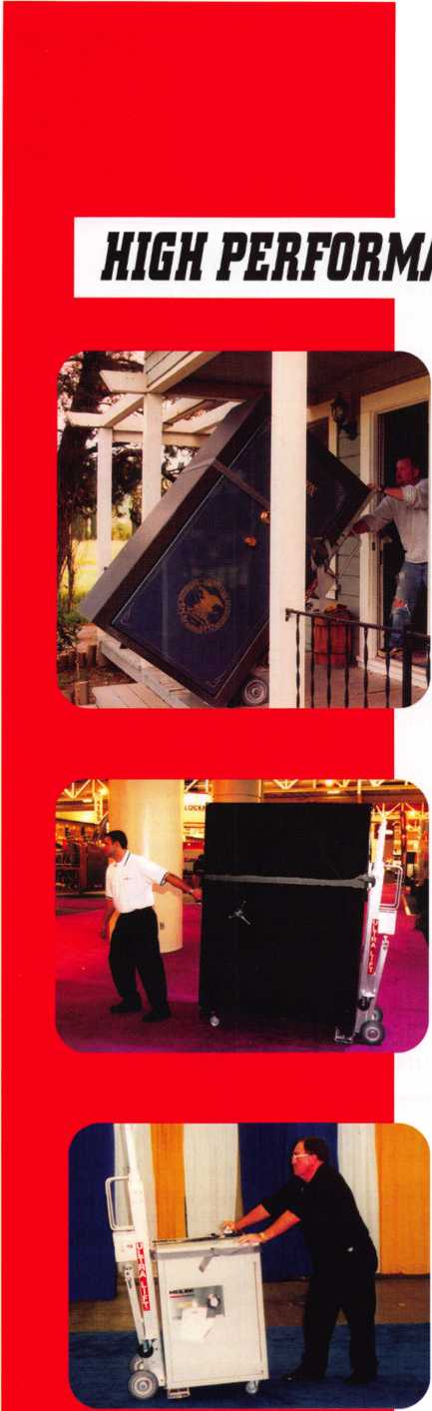

Distributor

**1st In Hardware, Inc.**

Phone: 866-397-9900 Fax: 866-646-0045 www. 1 stinhardware.com

**Accredited Lock Supply Co.**

Phone: 800-652-2835 Fax: 201-865-0030 [www.acclock.com](http://www.acclock.com)

**Andrews Wholesale Lock Supply**

Phone: 717-272-7422 Fax: 717-274-8659 [www.andrewslock.com](http://www.andrewslock.com)

**Boyle & Chase Inc.**

Phone: 800-325-2530 Fax: 800-205-3500 [www.boyleandchase.com](http://www.boyleandchase.com)

**Clark Security Products**

Phone: 888-784-1311 Fax: 619-718-7333 [www.clarksecurity.com](http://www.clarksecurity.com)

**Cook's Building Specialties**

Phone: 505-883-5701 Fax: 505-883-5704

**Dire's Lock & Key Company**

Phone: 303-294-0176 Fax: 303-294-0198

**Direct Security Supply, Inc.**

Phone: 800-252-5757 Fax: 800-452-8600

**Discount Key Machines.Com/Busch**

Phone: 800-332-8724 Fax: 407-363-4666

**Doyle Security Products**

Phone: 800-333-6953 Fax: 612-521-0166 [www.doylesecurity.com](http://www.doylesecurity.com)

**Dugmore and Duncan, Inc.**

Phone: 888-384-6673 Fax: 888-329-3846

**Ewert Wholesale Hardware**

Phone: 800-451-0200 Fax: 708-597-0881

**Foley-Belsaw Company**

Phone: 800-821-3452 Fax: 816-483-5010 [www.foley-belsaw.com](http://www.foley-belsaw.com)

**Fried Brothers Inc.**

Phone: 800-523-2924 Fax: 215-592-1255 [www.fbisecurity.com](http://www.fbisecurity.com)

**Hans Johnsen Company**

Phone: 214-879-1550 Fax: 214-879-1530

**Hardware Agencies, Ltd.**

Phone: 416-462-1921 [www.hardwareagencies.com](http://www.hardwareagencies.com)

**1DN Incorporated**

Phone: 817-421-5470 Fax: 817-421-5468 [www.idn-inc.com](http://www.idn-inc.com)

**Instant Hardware Delivery, Inc**

Phone: 800-355-1 107 Fax: 800-663-8518

**Intermountain Lock & Supply**

Phone: 800-453-5386 Fax: 801-485-7205 [www.intermountainlock.com](http://www.intermountainlock.com)

**International Electronics, Inc**

Phone: 800-343-9502 Fax: 617-821-4443

**Lockmasters, Inc.**

Phone: 859-885-6041 Fax: 859-885-7093 [www.lockmasters.com](http://www.lockmasters.com)

**Locks Company**

Phone: 800-288-0801 Fax: 305-949-3619

**Locksmith Ledger International**

Phone: 770-886-0800 Fax: 770-889-7703 [www.lledger.com](http://www.lledger.com)

**McDonald Dash Locksmith Supply**

Phone: 800-238-7541 Fax: 901-366-0005 [www.mcdonalddash.com](http://www.mcdonalddash.com)

**Monaco Lock Co.**

Phone: 800-526-6094 Fax: 800-845-5625 [www.monacolock.com](http://www.monacolock.com)

**Omaha Wholesale Hardware**

Phone: 800-238-4566 Fax: 402-444-1664 [www.omahawh.com](http://www.omahawh.com)

**RA-Lock Company**

Phone: 972-775-6301 Fax: 972-775-6316 [www.ralock.com](http://www.ralock.com)

**Security Distributors Inc**

Phone: 800-333-6953 Fax: 612-524-0166

**Security House**

Phone: 905-669-5300 Fax: 905-660-6313 [www.securityhouselock.com](http://www.securityhouselock.com)

**Security Lock Distributors**

Phone: 800-847-5625

Fax: 800-878-6400

[www.securitylockdistributors.com](http://www.securitylockdistributors.com)

**Southern Lock and Supply Co.**

Phone: 727-541-5536 Fax: 727-544-8278 [www.southernlock.com](http://www.southernlock.com)

**Stone & Berg Wholesale**

Phone: 800-225-7405 Fax: 800-535-5625

**The Locksmith Store Inc.**

Phone: 847-364-5111 Fax: 847-364-5125 [www.locksmithstore.com](http://www.locksmithstore.com)

**Timemaster Inc.**

Phone: 859-259-1878 Fax: 859-255-0298 [www.time-master.com](http://www.time-master.com)

**Top Notch Distributors, Inc.**

Phone: 800-233-4210 Fax: 800-854-4146 [www.topnotch.bz](http://www.topnotch.bz)

**Turn 10 Wholesale**

Phone: 800-848-9790 Fax: 800-391-4553

**U.S. Lock Corp.**

Phone: 800-925-5000 Fax: 800-338-5625 [www.uslock.com](http://www.uslock.com)

**Wilson Safe Company**

Phone: 215-492-7100 Fax: 215-492-7104 [www.wilsonsafe.com](http://www.wilsonsafe.com)

Manufacturer

**A & B Safe Corporation**

Phone: 800-253-1267 Fax: 856-863-1208 [www.a-bsafecorp.com](http://www.a-bsafecorp.com)

**ABUS Lock Company**

Phone: 800-352-2287 Fax: 602-516-9934 [www.abus.com](http://www.abus.com)

**Access Security Products Ltd.**

Phone: 905-337-7874 Fax: 905-337-7873 [www.access-safe.com](http://www.access-safe.com)

**Adams Rite Mfg Company**

Phone: 800-872-3267 Fax: 800-232-7329 [www.adamsrite.com](http://www.adamsrite.com)

**Adesco Safe Mfg. Company**

Phone: 800-694-9340 Fax: 562-408-6427 [www.adesco.com](http://www.adesco.com)

**Adrian Steel Company**

Phone: 800-677-2726 Fax: 517-265-5834 [www.adriansteel.com](http://www.adriansteel.com)

**Advanced Diagnostics USA Inc**

Phone: 650-876-2020 Fax: 650-876-2022 [www.ad-mvp.com](http://www.ad-mvp.com)

**All Five Tool Company, Inc.**

Phone: 860-583-1691 Fax: 860-583-4516 [www.all5tool.com](http://www.all5tool.com)

**American Security Products**

Phone: 909-685-9680X1083 Fax: 909-685-9685 [www.amsecusa.com](http://www.amsecusa.com)

**Bianchi USA, Inc.**

Phone: 800-891-2118 Fax: 216-803-0202

**Buddy Products**

Phone: 800-886-8688 Fax: 312-733-8356 [www.buddyproducts.com](http://www.buddyproducts.com)

**CCL Security Products**

Phone: 800-733-8588 Fax: 847-537-1 800

**COMPX Security Products**

Phone: 864-297-6655 Fax: 864-297-9987 [www.compxnet.com](http://www.compxnet.com)

**D&D Technologies (USA), Inc.**

Phone: 714-677-1300X292 Fax: 714-677-1299 [www.ddtechusa.com](http://www.ddtechusa.com)

**DETEX Corp.**

Phone: 800-729-3839 Fax: 830-620-6711 [www.detex.com](http://www.detex.com)

**Don-Jo Manufacturing, Inc.**

Phone: 978-422-3213 Fax: 978-422-3467 [www.don-jo.com](http://www.don-jo.com)

**Door Controls International**

Phone: 800-742-3634 Fax: 800-742-0410 [www.doorcontrols.com](http://www.doorcontrols.com)

**FireKing Security Products**

Phone: 800-457-2424 Fax: 800-896-6606 [www.fkisecuritygroup.com](http://www.fkisecuritygroup.com)

Keynotes • September 2005

**associate**

members

**Framon Manufacturing Company Inc.**

Phone: 989-354-5623 Fax: 989-354-4238 [www.framon.com](http://www.framon.com)

**HY-KO Products Co.**

Phone: 330-467-7446 Fax: 330-467-7442

**Hammerhead Industries, Inc.**

Phone: 805-658-9922 Fax: 805-658-8833 [www.gearkeeper.com](http://www.gearkeeper.com)

**Ingersoll Rand SSA**

Phone: 317-613-8025 Fax: 317-613-8068 [www.schlagelock.com](http://www.schlagelock.com)

**Jackson Corporation**

Phone: 323-269-81 1 1 Fax: 800-888-6855 [www.jacksonexit.com](http://www.jacksonexit.com)

**Jet Hardware Mfg., Co.**

Phone: 718-257-9600 Fax: 718-257-0973 [www.jetkeys.com](http://www.jetkeys.com)

**KABA ILCO Corp.**

Phone: 252-446-3321 Fax: 252-446-4702 [www.kaba-ilco.com](http://www.kaba-ilco.com)

**KEY-BAK/West Coast Chain Mfg.**

Phone: 909-923-7800 Fax: 909-923-0024 [www.keybak.com](http://www.keybak.com)

**Keri Systems Inc.**

Phone: 408-451-2520 Fax: 408-441-0309 [www.kerisys.com](http://www.kerisys.com)

**Knaack Manufacturing Co.**

Phone: 800-456-7865 Fax: 815-459-9097 [www.weatherguard.com](http://www.weatherguard.com)

**LAB Security**

Phone: 800-243-8242 Fax: 860-583-7838 [www.labpins.com](http://www.labpins.com)

**La Gard Inc.**

Phone: 310-325-5670 Fax: 310-325-5615 [www.lagard.com](http://www.lagard.com)

**Lock America, Inc. dba L.A.I. Group**

Phone: 714-373-2993 Fax: 714-373-2998 [www.laigroup.com](http://www.laigroup.com)

**Lucky Line Products, Inc.**

Phone: 858-549-6699 Fax: 858-549-3241 [www.luckyline.com](http://www.luckyline.com)

**M.A.G. Manufacturing**

Phone: 714-891-5100 Fax: 714-892-6845 [www.magmanufacturing.com](http://www.magmanufacturing.com)

**MUL-T-LOCK USA, Inc.**

Phone: 800-562-351 1 Fax: 973-778-4007 [www.mul-t-lock.com](http://www.mul-t-lock.com)

**Major Mfg, Inc.**

Phone: 714-772-5202 Fax: 714-772-2302 [www.majormfg.com](http://www.majormfg.com)

**Maxcess Card Systems Ltd**

Phone: 949-492-5964 Fax: 949-492-0415 [www.maxcess-card.com](http://www.maxcess-card.com)

**Medeco Security Locks**

Phone: 540-380-5000 Fax: 540-380-5010 [www.medeco.com](http://www.medeco.com)

**Mil-Comm Products Co Inc**

Phone: 201-935-8561 Fax: 201-935-6059

**ROFU International Corp.**

Phone: 253-922-1828 Fax: 253-922-1728 [www.rofu.com](http://www.rofu.com)

**Rutherford Controls Int'l Co.**

Phone: 757-427-1230 Fax: 757-427-9549 [www.rutherfordcontrols.com](http://www.rutherfordcontrols.com)

**STRATTEC Security Corp.**

Phone: 414-247-3415 Fax: 414-247-3692 [www.strattec.com](http://www.strattec.com)

**Sargent & Greenleaf, Inc.**

Phone: 800-826-7652X201 Fax: 859-885-3063 [www.sargentandgreenleaf.com](http://www.sargentandgreenleaf.com)

**Sargent Manufacturing Co.**

Phone: 800-727-5477 Fax: 888-863-5054 [www.sargentlock.com](http://www.sargentlock.com)

**Schwab Corp.**

Phone: 765-447-9470 Fax: 765-447-8278 [www.schwabcorp.com](http://www.schwabcorp.com)

**Securifort Inc**

Phone: 819-359-2226 Fax: 819-359-2218 [www.securifort.com](http://www.securifort.com)

**Securitron Magnalock Corp.**

Phone: 775-355-5625 Fax: 775-355-5636 [www.securitron.com](http://www.securitron.com)

**Security Door Controls**

Phone: 805-494-0622 Fax: 805-494-8861 [www.sdcsecurity.com](http://www.sdcsecurity.com)

**Security Solutions**

Phone: 405-376-1600 Fax: 405-376-6870 [www.securitysolutions-usa.com](http://www.securitysolutions-usa.com)

**Townsteel, Inc.**

Phone: 626-858-5080 Fax: 626-858-3393 [www.townsteel.com](http://www.townsteel.com)

**UCA Inc**

Phone: 972-312-0599X12 Fax: 972-692-7056 [www.ibuttonlock.com](http://www.ibuttonlock.com)

**Ultra Lift Corporation**

Phone: 800-346-3057 Fax: 408-297-1199 [www.ultralift.com](http://www.ultralift.com)

**Videx Inc.**

Phone: 541-758-0521 Fax: 541-752-5285 [www.videx.com](http://www.videx.com)

**YSG Door Security Consultants, Inc.**

Phone: 800-438-1951 Fax: 800-338-0965

Service

Organization

**Allstate Insurance Company**

Phone: 800-859-0247 Fax: 847-326-7509 [www.allstate.com](http://www.allstate.com)

**Cross Country Automotive Services**

Phone: 800-541-2262 Fax: 781-393-0256 [www.argosi.com](http://www.argosi.com)

**Massglass & Door Service**

Phone: 888-742-8837 Fax: 805-497-2255 [www.massglass.com](http://www.massglass.com)

**Webster Safe & Lock Co., Inc.**

Phone: 901-332-2911 Fax: 901-332-2878 [www.webstersinc.com](http://www.webstersinc.com)



Keynotes • September 2005

|  |  |  |  |  |  |
| --- | --- | --- | --- | --- | --- |
| 11 | 1 e c  V. | j i s | 1 a 1 | i v | e |
| jj | u p | d a 1 | \ e |  |  |

House Again Passes Association Health Plan Legislation; Pressure on Senate Builds

With Congress in recess during the month of August (returning after Labor Day), the timing of House passage of the Association Health Plan (AHP) legislation (H.R. 525) at the end of July is certainly beneficial to ALOA members. The strong bipartisan vote (263-165, with all Republicans and 36 Democrats supporting) in favor of the AHP bill in the House, combined with recent public opinion polls showing general dis­satisfaction with the Republican-led Congress, will put further pressure on the Senate to finally take action on small busi­ness health insurance reform.

While the pace is substantially slower while Congress is in recess, work never­theless continues at the staff level in preparation for activity in September. Sources indicate that Senator Enzi and his staff continue to work on a small business health insurance reform bill that will include Association Health Plans in some form (although they will likely be called something else). Also, White House and Department of Labor officials have recent­ly met with Senator Enzi's staff to discuss the AHP legislation. Thus, it is expected that Senator Enzi will attempt to move his legislation through the Senate Health, Education, Labor and Pensions Committee in the fall. This will be an extremely criti­cal time for the AHP legislation!

This month presents great opportunities for grass-roots contacts with Senators who are back in their home states. It is important that organizations continue contacts with Senators, especially those who sit on the Senate HELP Committee, at this time (see attached target list and sample letters). Senators on the HELP Committee should be urged to support Senator Enzi's effort to move forward with legislation that retains the major components of AHP leg­islation (S. 406). In contacting Senators who are not on the HELP Committee,

continue to urge them to become a cosponsor of S. 406. Feel free to reference the strong House vote on the AHP bill in any contacts with Senators. For example, in contacts with Senator Lamar Alexander (R-TN), a member of the Senate HELP Committee who is undecided on S. 406, you might want to point out that all Tennessee House Republicans, and four out of five Tennessee House Democrats, voted in favor of H.R. 525. This is just another method of sending the message that the Senator should get with the pro­gram.

Senate Cosponsors of the Small Business

Health Fairness Act (S. 406)

Olympia Snowe (R-ME)

Kit Bond (R-MO)

Jim Talent (R-MO)

Elizabeth Dole (R-NC)

John McCain (R-AZ)

Norm Coleman (R-MN)

Kay Bailey Hutchison (R-TX)

Arlen Specter (R-PA)

Robert Byrd (D-WV)

Johnny Isakson (R-GA)

Mel Martinez (R-FL)

John Thune (R-SD)

David Vitter (R-LA)

Senate Target List (updated July 12, 2005)

Republicans

Mike Enzi (R-WY), Chair, Senate Health, Education, Labor and Pensions Committee*

Rick Santorum (R-PA), Senate Republican Conference Chair

Jon Kyi (R-AZ), Senate Republican Policy Committee Chair

Judd Gregg (R-NH)*

Lamar Alexander (R-TN)*

Richard Burr (R-NC)*

Mike DeWine (R-OH)*

Pat Roberts (R-KS) *

John Ensign (R-NV)*

Orrin Hatch (R-UT)*

Jeff Sessions (R-AL) *

Lindsey Graham (R-SC)

Jim DeMint (R-SC)

Charles Grassley (R-IA)

John Warner (R-VA)

George Allen (R-VA)

Wayne Allard (R-CO)

Craig Thomas (R-WY)

Robert Bennett (R-UT)

Chuck Hagel (R-NE)

Conrad Burns (R-MT)

John Sununu (R-NH)

Sam Brownback (R-KS)

Gordon Smith (R-OR)

John Cornyn (R-TX)

George Voinovich (R-OH)

Susan Collins (R-ME)

Democrats

Joseph Lieberman (D-CT)

Ken Salazar (D-CO)

Barack Obama (D-IL)

Mary Landrieu (D-LA)

Jeff Bingaman (D-NM)*

Patty Murray (D-WA)*

Barbara Mikulski (D-MD)*

Jack Reed (D-RI)*

Dianne Feinstein (D-CA)

Tim Johnson (D-SD)

* Member of the Senate Health, Education, Labor and Pensions (HELP) Committee



DRAFT LETTER TO SENATORS (ON HELP COMMITTEE)

The Honorable (Full Name of Senator)

U.S. Senate

Washington, DC 20510 Dear Senator (last name):

I am writing to urge you to support the efforts of Senator Mike Enzi to develop "insurance market reform" legislation that retains the core components of the Small Business Health Fairness Act (S. 406). As a member of the Senate Committee on Health Education, Labor and Pensions, you can play an integral role in the development of the legislation that allows Association Health Plans to provide affordable health benefits to small and mid-sized employers.

With health insurance premiums increasing at alarming rates, small businesses need new options that will allow them to provide afford­able health care benefits to their employees. S. 406 will accomplish this goal by allowing Association Health Plans to utilize the same tools which corporate and labor union health plans use to keep health benefits affordable. This legislation will provide small businesses, via AHPs sponsored by trade and professional associations, with greater bargaining power and administrative efficiencies, the option of self-funding, and greater flexibility to design benefit options that meet the needs of working families. It is only fair that small businesses have similar opportunities to operate health plans that Congress has already granted to large corporations and labor unions, and only the core components of S. 406 will accomplish this objective.

With the power of group purchasing through bona fide trade and professional associations, small businesses can obtain cost savings of 15-20% on health care benefits. S. 406 will strengthen and expand AHPs, thus helping to ensure that working families employed by small and mid-sized firms have access to affordable and secure health benefits. The bill contains provisions aimed at ensuring there are no adverse impacts on existing insurance markets, and strong solvency protections to ensure that benefits provided through AHPs are secure.

I strongly urge you to work with Senator Enzi to develop legislation that retains the core components of S. 406. Thank you for your con­sideration, and I look forward to receiving your response on this important matter.

Sincerely,

DRAFT LETTER TO SENATORS (NOT ON HELP COMMITTEE)

The Honorable (Full Name of Senator)

U.S. Senate

Washington, DC 20510 Dear Senator (last name):

I am writing to urge you to cosponsor the Small Business Health Fairness Act (S. 406), which will make health care benefits affordable for small and mid-sized employers. This bill, also known as Association Health Plan (AHP) legislation, is cosponsored by Senators Snowe (R- ME), Talent (R-MO), Byrd (D-WV) and others.

With health insurance premiums increasing at alarming rates, small businesses need new options that will allow them to provide afford­able health care benefits to their employees. S. 406 will accomplish this goal by allowing Association Health Plans to utilize the same tools which corporate and labor union health plans use to keep health benefits affordable. This legislation will provide small businesses, via AHPs sponsored by trade and professional associations, with greater bargaining power and administrative efficiencies, the option of self-funding, and greater flexibility to design benefit options that meet the needs of working families. It is only fair that small and medium­sized businesses have similar opportunities to operate health plans that Congress has already granted to large corporations and labor unions, and only S. 406 will accomplish this objective.

With the power of group purchasing through bona fide trade and professional associations, small businesses can obtain cost savings of 15-20% on health care benefits. S. 406 will strengthen and expand AHPs, thus helping to ensure that working families employed by small and mid-sized firms have access to affordable and secure health benefits. The bill contains provisions aimed at ensuring there are no adverse impacts on existing insurance markets, and strong solvency protections to ensure that benefits provided through AHPs are secure.

I strongly urge you to cosponsor S. 406 in the 109th Congress. Thank you for your consideration, and I look forward to receiving your response on this important matter.

Sincerely,



Keynotes • September 2005



Punch SARGENT Blanks to Factory Specifications.

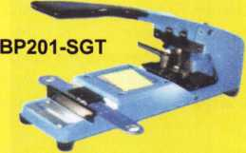

Try it hands on @ ALOA  
in Rosemont, IL

Available Exclusively from:

**Locksmithing, UNL. LLC  
302**-**575-0993**

**[www.locksmithingunl.com](http://www.locksmithingunl.com)**

IN-STOCK...MORE SAFES

***FREE Freight Program***

***(30 States)***

**AMSEC** FireKing **Gaidai HAYMAN meiunk** Victor

**TURD ID**

**WHOLESALE SERVICE**

800-848-9790

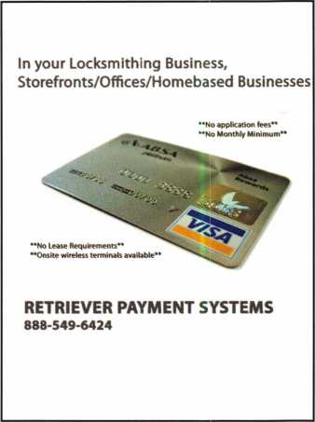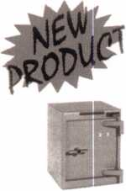

FROM A & B SAFE C0RP.

A & B Chest  
Model WS-0

Equipped with dual key,  
combination or  
electronic locking  
slot optional

A & B SAFE CORPORATION

171 S. Del sea Dr.  
Glassboro, NJ 08028*6237  
856-863-1186 Fax 856-863-1208

Broken/Cracked  
door jamb??

Don't replace/Don't rebuildl!

"Kwik Jam"

[www.PEBent.com](http://www.PEBent.com)

***Punch SARGENT blanks to factory specification*s.**

This was our booth banner at the annual A.L.O.A. 2005 Security Expo as our  
BP201-SGT-L and SGT-R punches made their debut to many eager attendees.  
These models were made from our own parts and added to a modified PRO-LOK  
chassis. Sales, service and warranties are available from Locksmithing, Uni. LLC  
**ONLY**, and not through PRO-LOK. They will cut both L and R Series original  
key blanks up to 7 spaces, and to factory specifications including spaces, depths,  
angle and tolerances. Having been evaluated by SARGENT, a distributor, and  
locksmiths, both models are now available with price, delivery, and warranties.

**[ Phone: 302-575-0993 • Fax: 302-571-1677 • Web: [www.sargentpunch.com](http://www.sargentpunch.com) • E-Mail: [ted@sargentpunch.com](mailto:ted@sargentpunch.com) |**

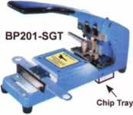

Keynotes • September 2005

iNKAS®is the leader in financial solutions. We have built our reputation by delivering reliable, high quality and competitively priced products to our customers all over North America. INKAS is committed to providing high quality, high value and the support to match.

Dealerships and distributorship still available

Safes & Vaults

A.T.M & P.O.S Terminals

Armored

Courier

Service

1 -877-GO-INKAS

**or [www.inkas.ca](http://www.inkas.ca)**

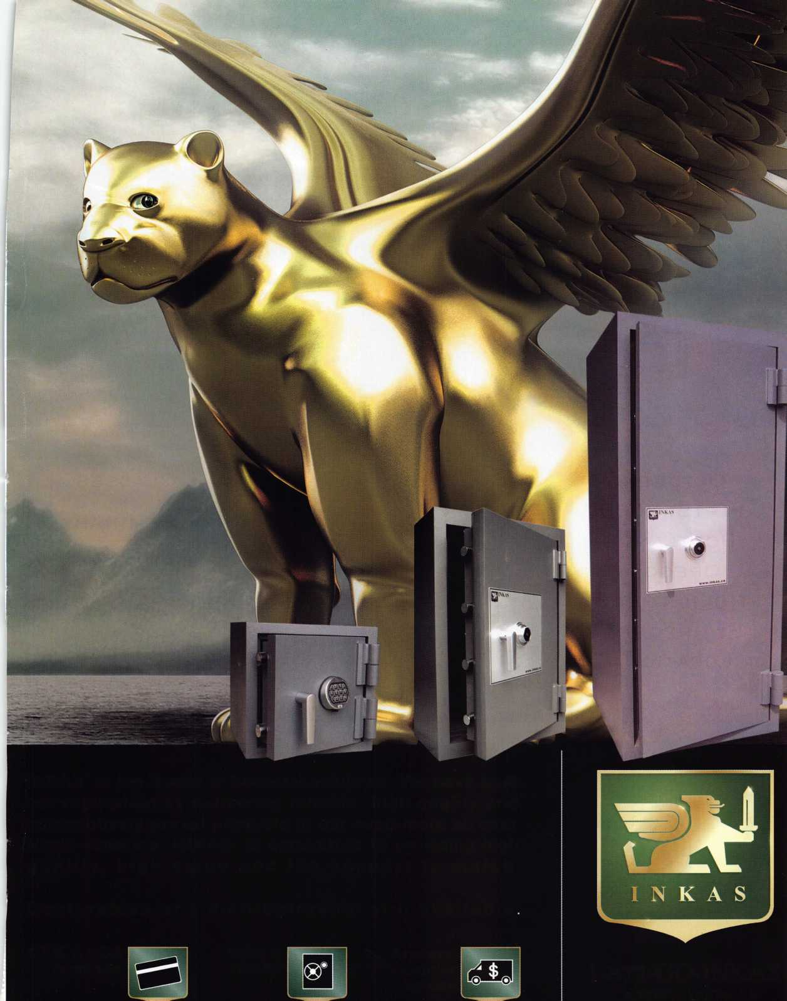

**2005 Pacific Locksmith**

conference

**October**1 1-15, 2005  
**Portland,  
Oregon  
Holiday Inn  
(Airport  
Location)**

* **Classes**
* **Seminars**
* **PRP Exam**
* **Trade Show**

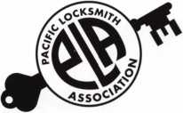

**Are you Ready to take**

YOUR BUSINESS TO THE

NEXT LEVEL?

BILL BOTEK, CRL • 503-644-988 1 • [BBOTEK@PRECISIONLOCKSMITH.COM](mailto:BBOTEK@PRECISIONLOCKSMITH.COM) • [WWW.PLA-PRO.ORG](http://WWW.PLA-PRO.ORG)

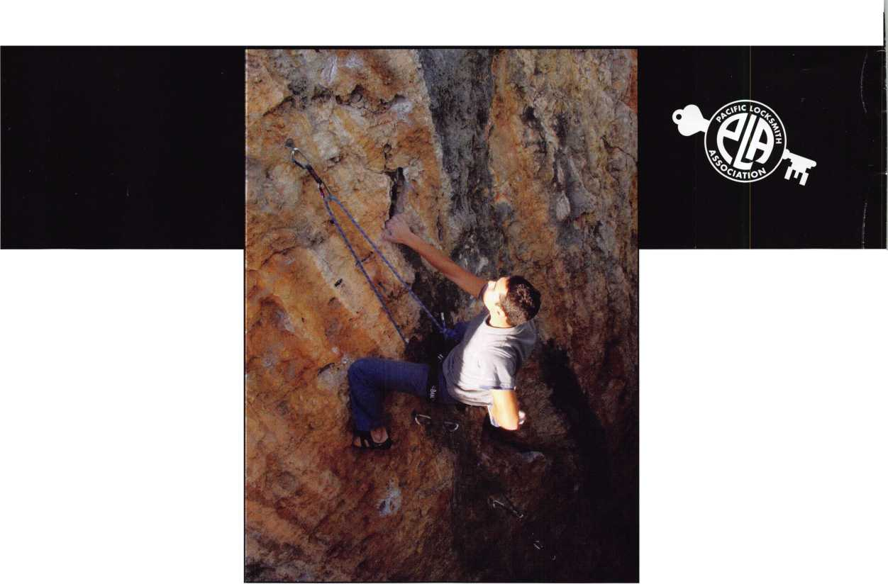

Thursi

**& TRADE SHOW**

**CLASS SCHEDULE**

Wednesday, November 2

CLASS 1

Keying Conferences and Hardware Recordkeeping

**FREE CLASS**

**Life Safety Codes  
For Locksmiths**

**NOW. 2 thrnunh 6**

27 YEARS

fowled*

**The Northeast's Premier Industry Event 1 Sturbridge Host Hotel in Sturbridge, MA**

* **15 Training Classes**

**PLUS FREE CLASS: Life Safety Codes for Locksmiths**

* **Two-Day Trade Show Event**
* **Over 100 Booths**
* **Many new products and tools**
* **Gift for registering**
* **Scenic location - bring the family!**

**For additional information and registration, visit us at [www.yankeesecurity.org](http://www.yankeesecurity.org)**

CLASS 9

ALOA Professional Lock Picking Techniques

CLASS 10

ALOA Motorcycle Locksmithing

fay, November 4

CLASS 11

Advanced Wiring Diagram Design

CLASS 12

Safe Lock Troubleshooting

CLASS 13

ALOA Mechanical Push Button Lock Manipulation

CLASS 14

ALOA Professional Lock Impressioning

CLASS 15

ALOA Studying For and Passing the PRP

I

A:!

CLASS 3

ALOA

Jail and Prison Locks

CLASS 4

ALOA

Alternative Entry Techniques

CLASS 8

ALOA Solving Electronic Codes, PINs and Code Lists

CLASS 2

First Aid & CPR Certification

ovember 3

'CERTIFICATION irammed & Electronics by IR

FACTORY CERTIFICATION Offline Electronic Access Control by IR

CLASS 5

ALOA Closed Circuit Television For Locksmiths

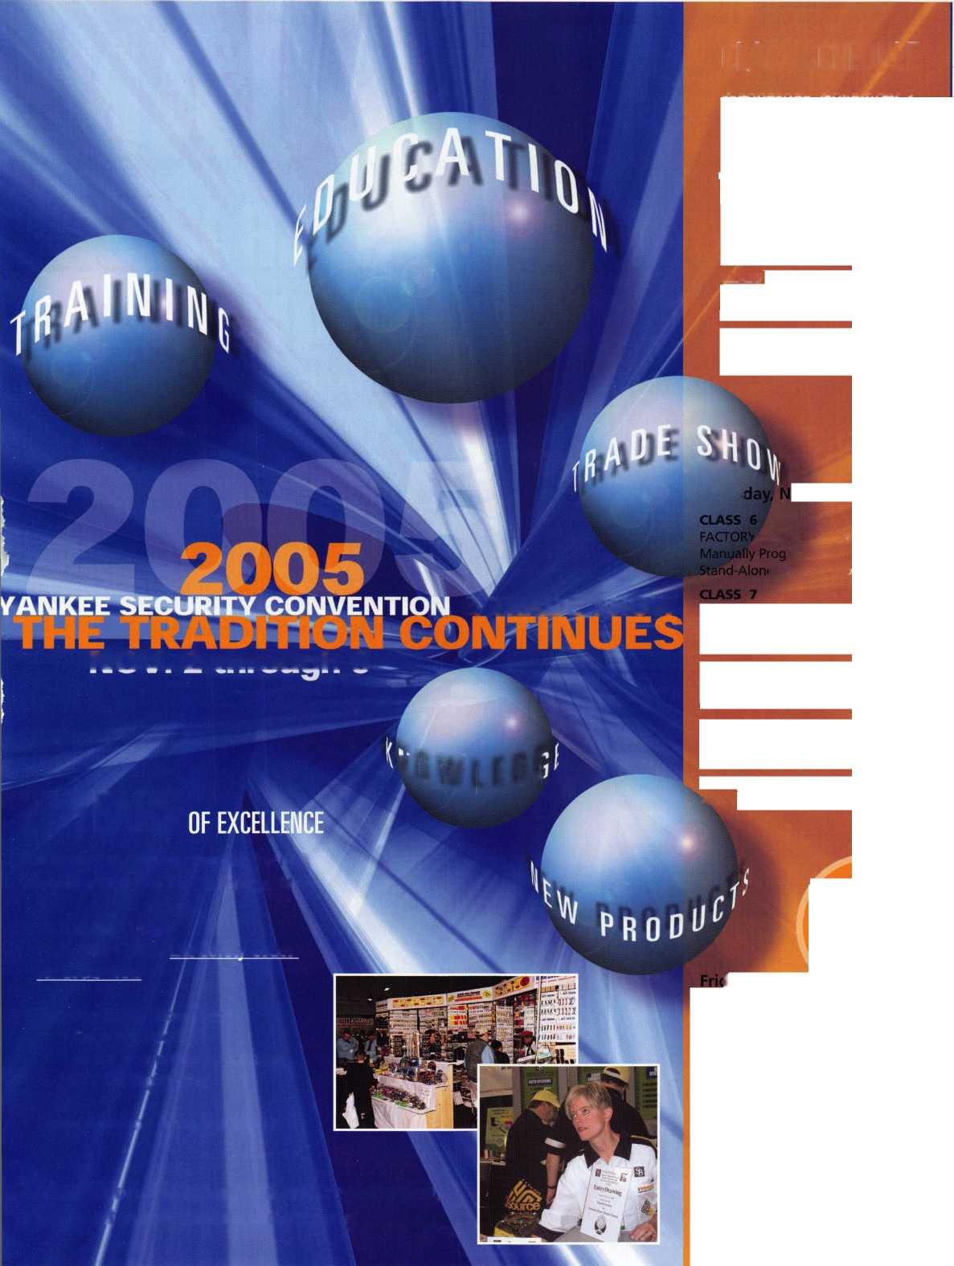

CANCEL

8008LXLC

CAN VIM

81201L

CAN

**Your**

**The most reliable unit available for transponder key programming and PATS system diagnostics on ALL Ford Lincoln/Mercury and Mazda* vehicles.**

**Mazda Transp**

(S

NG!

Locksm

CAN VIM

Vehicle Interface Module

HICKOK \ /A,

**CAN Vehicle Interface Module Model Software Update now**1 **availaBI^**

***TOLL FREEtichsuppobt***

***800/342******5080***

**HICKOK**

INCORPORATED

NGS XL CAN Locksmith Kit 8008LXLC

* NGS XL Tester and Locksmith VIM
* NGS XL CAN VIM
* 1996-Current Model Year Ford Transponder

PATS Reprogramming Software

* FREE - 2 Additional Years of Software
* 81204 - CAN Vehicle Interface Cable
* 81205 - CAN Power Cable
* 800N - OBDII/EEC-V Cable
* HI 05-00100 - Central Security Module Cable
* NGS/Locksmith/PATS Instruction Manual
* Key Blank/System Quick Reference Card
* Transponder Marketing Support Pack
* Blo-molded Carrying Case
* 13 Month Warranty

|  |  |
| --- | --- |
| NGS CAN VIM Kit 81201L | |
| • NGS CAN Vehicle Interface Module (VIM) | |
| • 81204-CAN Vehicle Int | erface Cable |
| • 81205 - CAN Auxiliary P | ower Cable |
| • 2003-2005 CAN Softwa | re Card |
| • 2005 Non-CAN Software | 2 Cards |
| • Operator's Manual |  |
| • Key Blank Quick Referen | ce Chart |

